Once the application is created for workflow and build , dist file gets created. And once the dist is created only in the workflow we can select it.

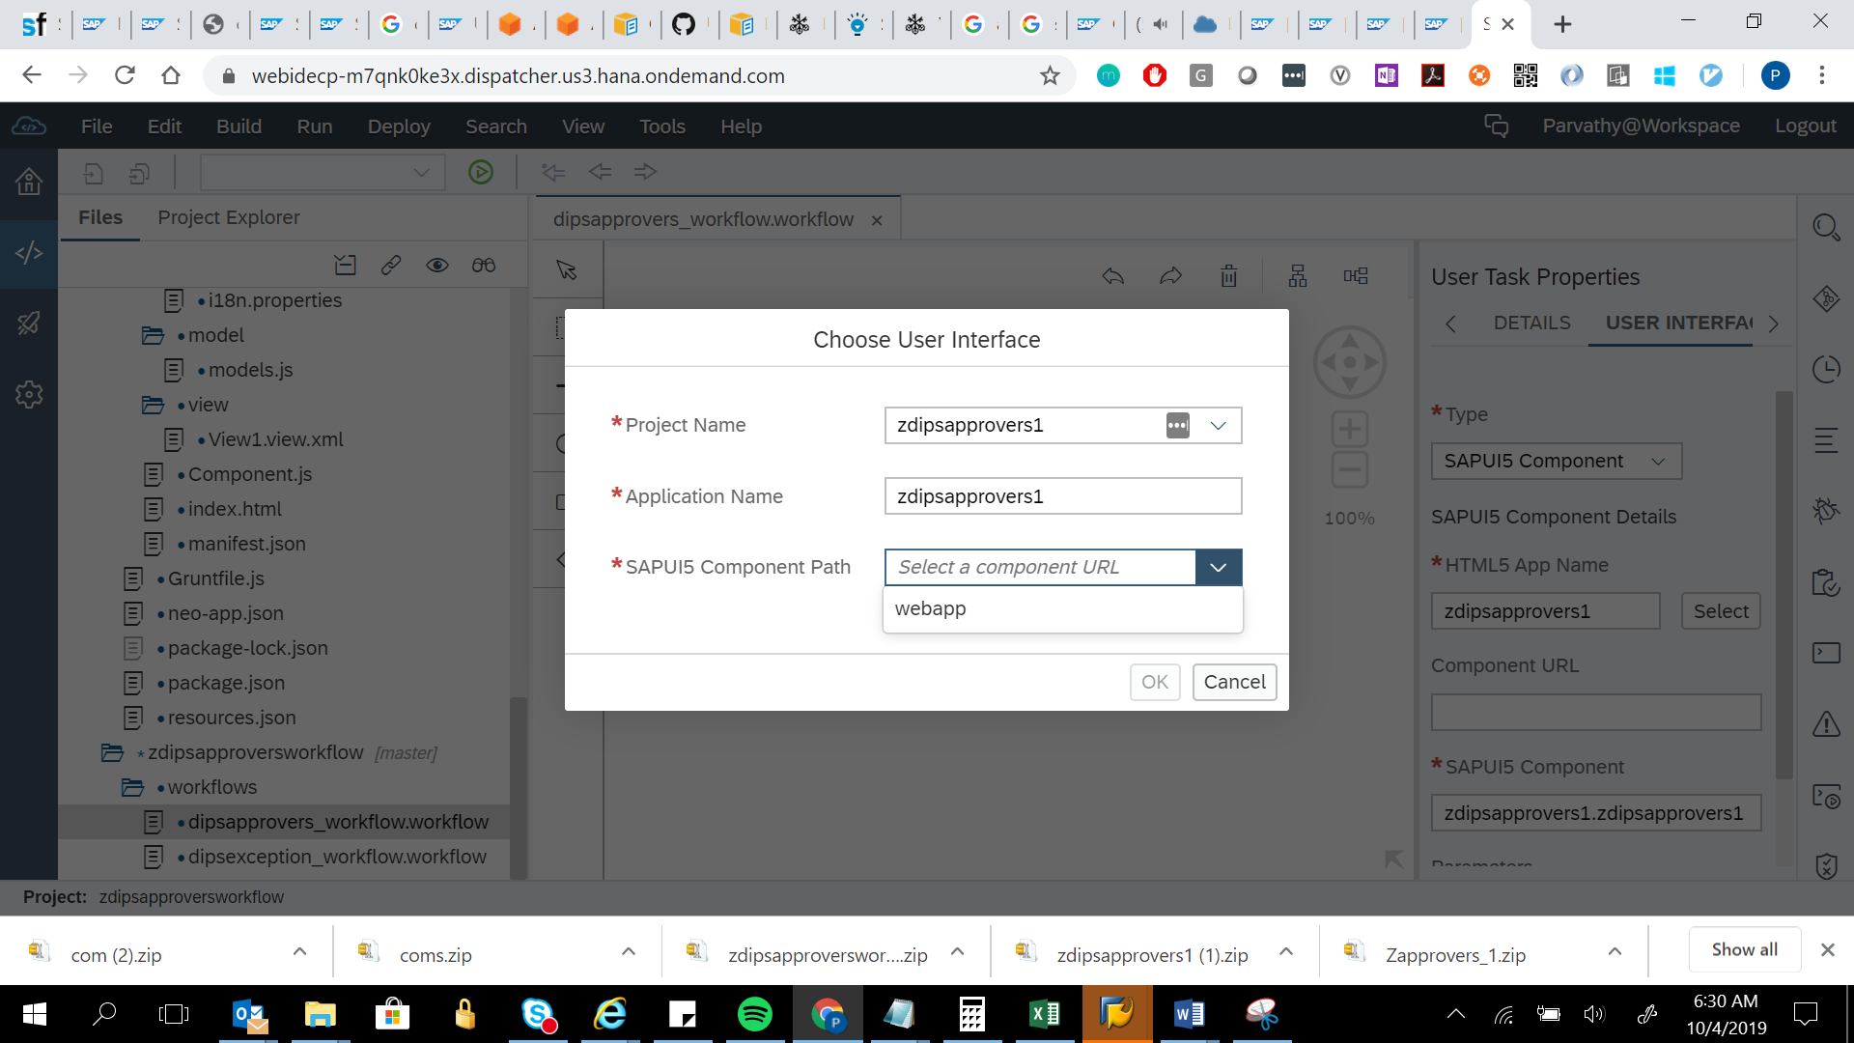

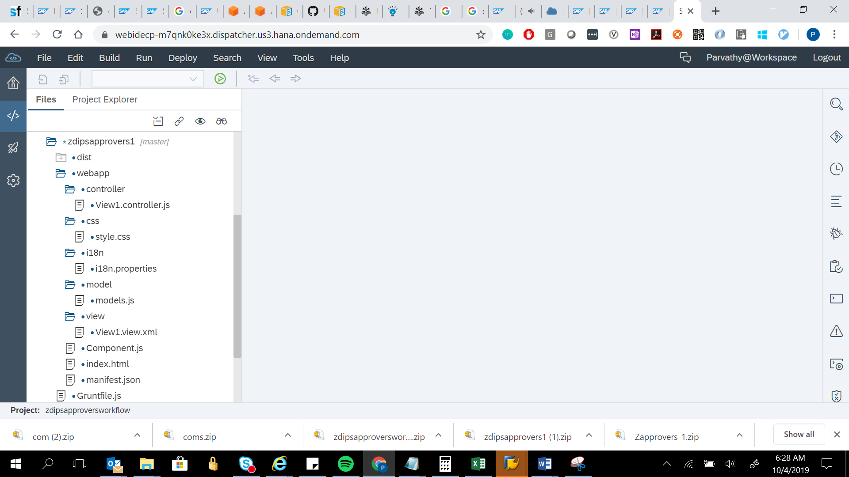

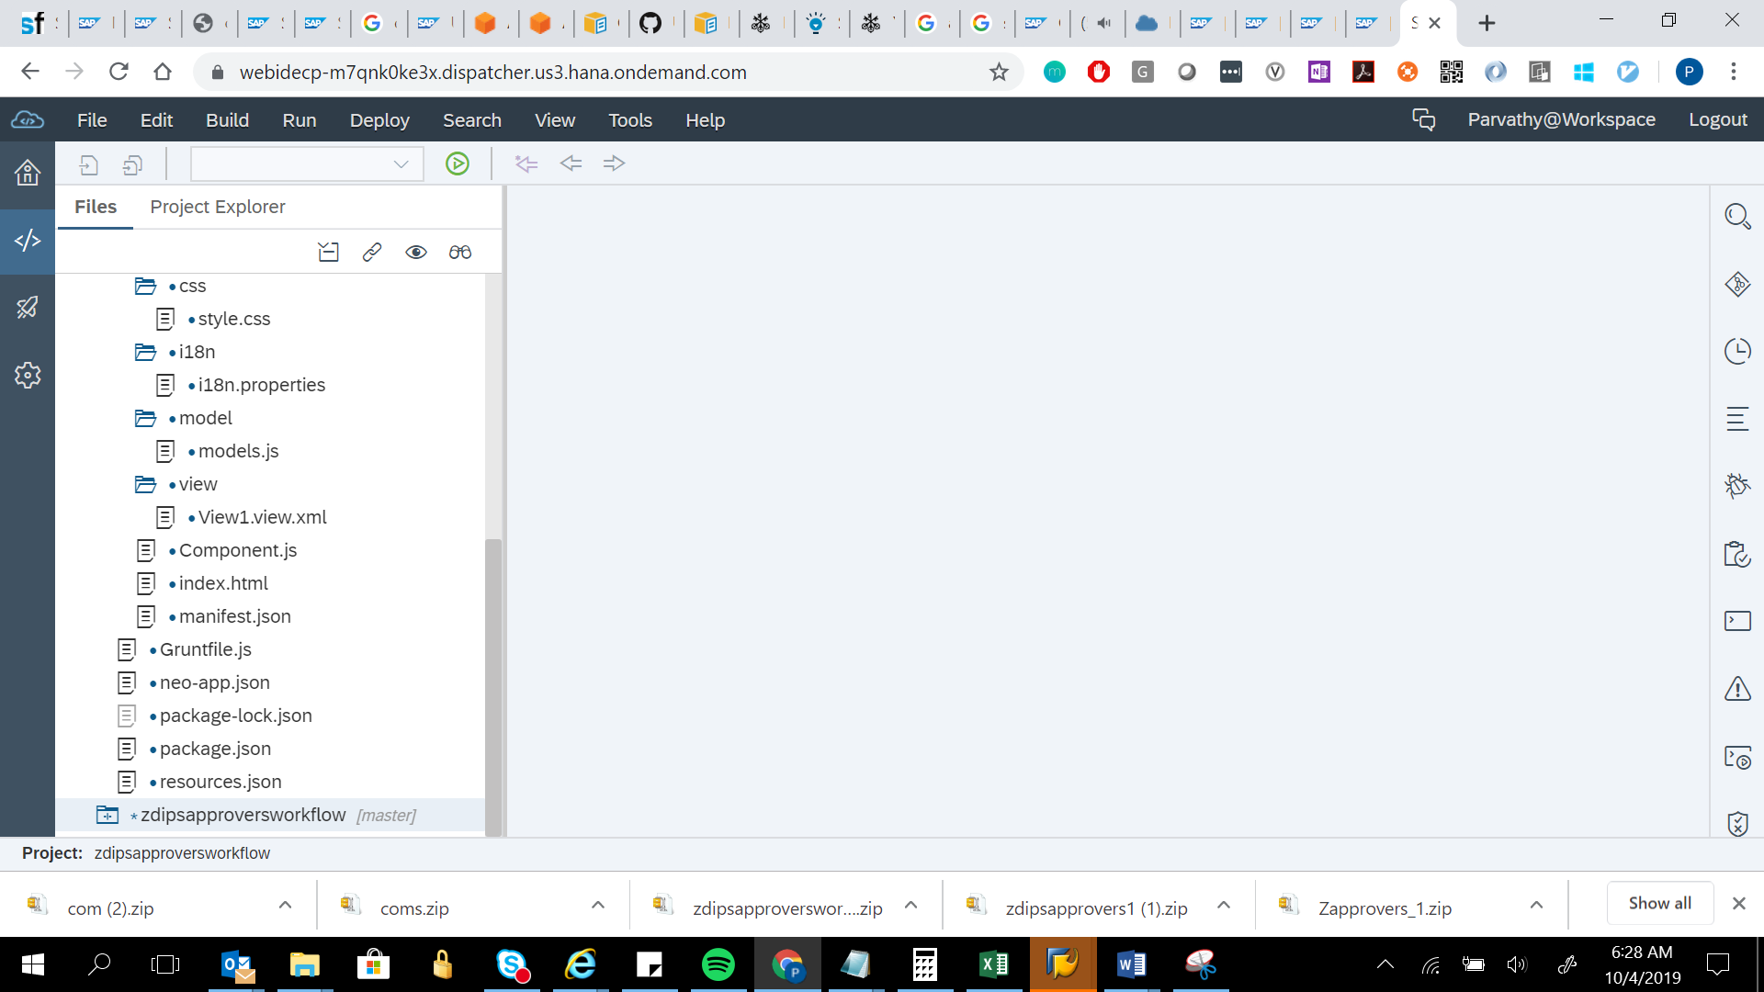

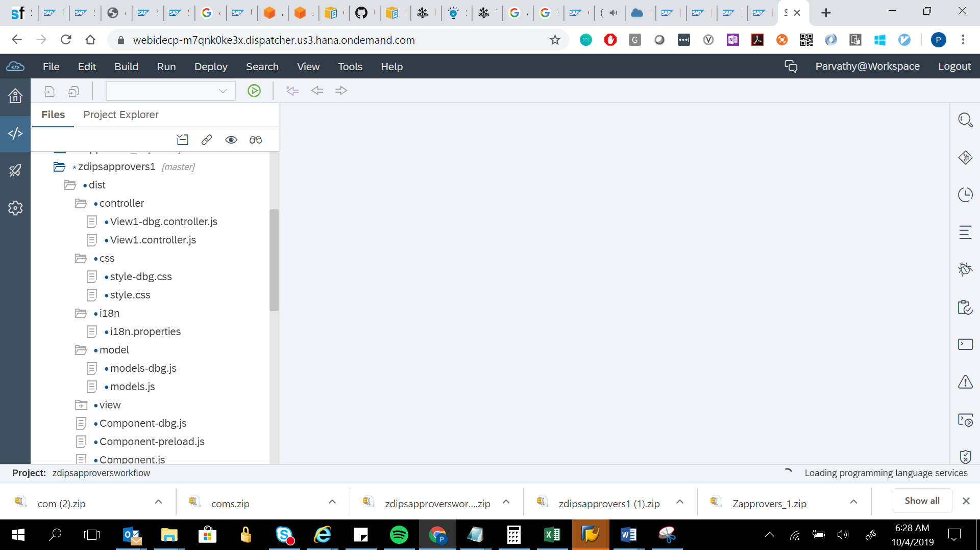

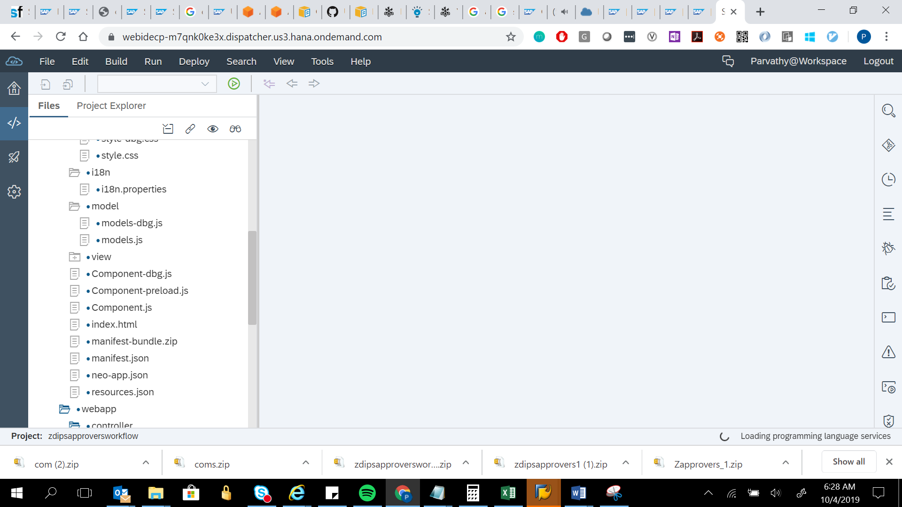

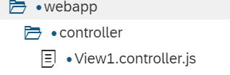

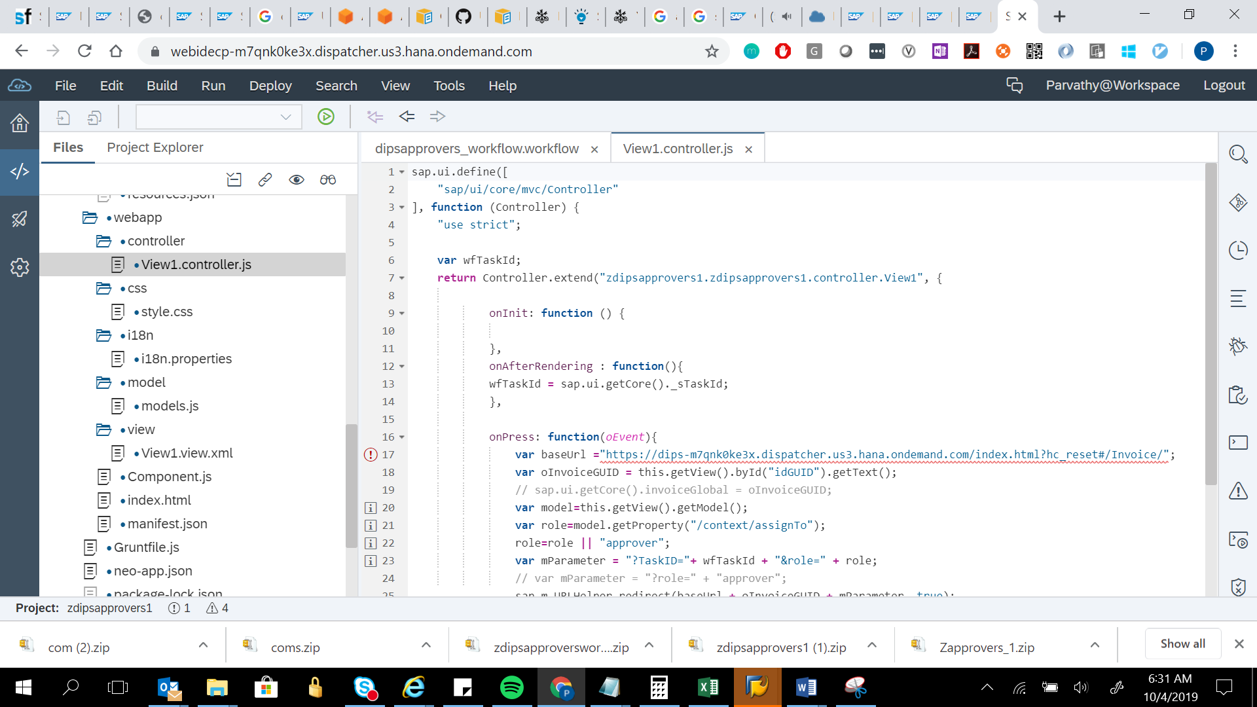

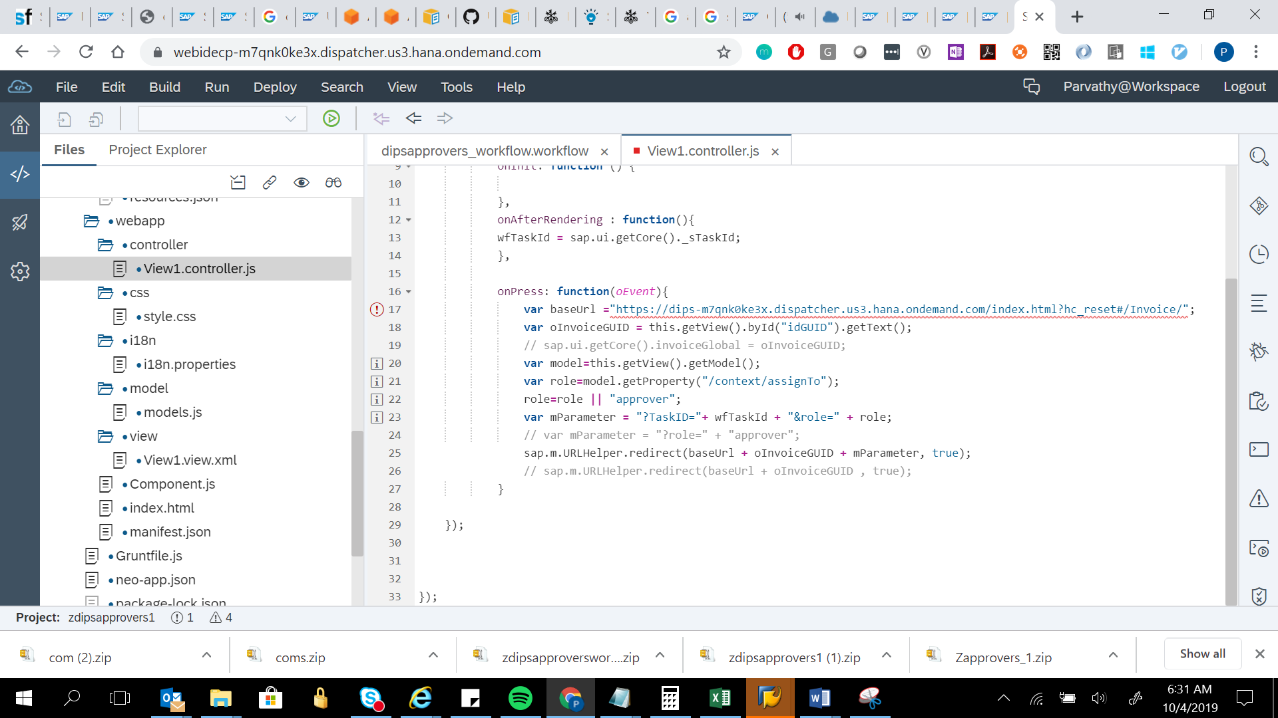

sap.ui.define([

"sap/ui/core/mvc/Controller"

], function (Controller) {

"use strict";

var wfTaskId;

return Controller.extend("zdipsapprovers1.zdipsapprovers1.controller.View1", {

onInit: function () {

},

onAfterRendering : function(){

wfTaskId = sap.ui.getCore()._sTaskId;

},

onPress: function(oEvent){

var baseUrl ="https://dips-m7qnk0ke3x.dispatcher.us3.hana.ondemand.com/index.html?hc_reset#/Invoice/";

var oInvoiceGUID = this.getView().byId("idGUID").getText();

// sap.ui.getCore().invoiceGlobal = oInvoiceGUID;

var model=this.getView().getModel();

var role=model.getProperty("/context/assignTo");

role=role || "approver";

var mParameter = "?TaskID="+ wfTaskId + "&role=" + role;

// var mParameter = "?role=" + "approver";

sap.m.URLHelper.redirect(baseUrl + oInvoiceGUID + mParameter, true);

// sap.m.URLHelper.redirect(baseUrl + oInvoiceGUID , true);

}

});

});



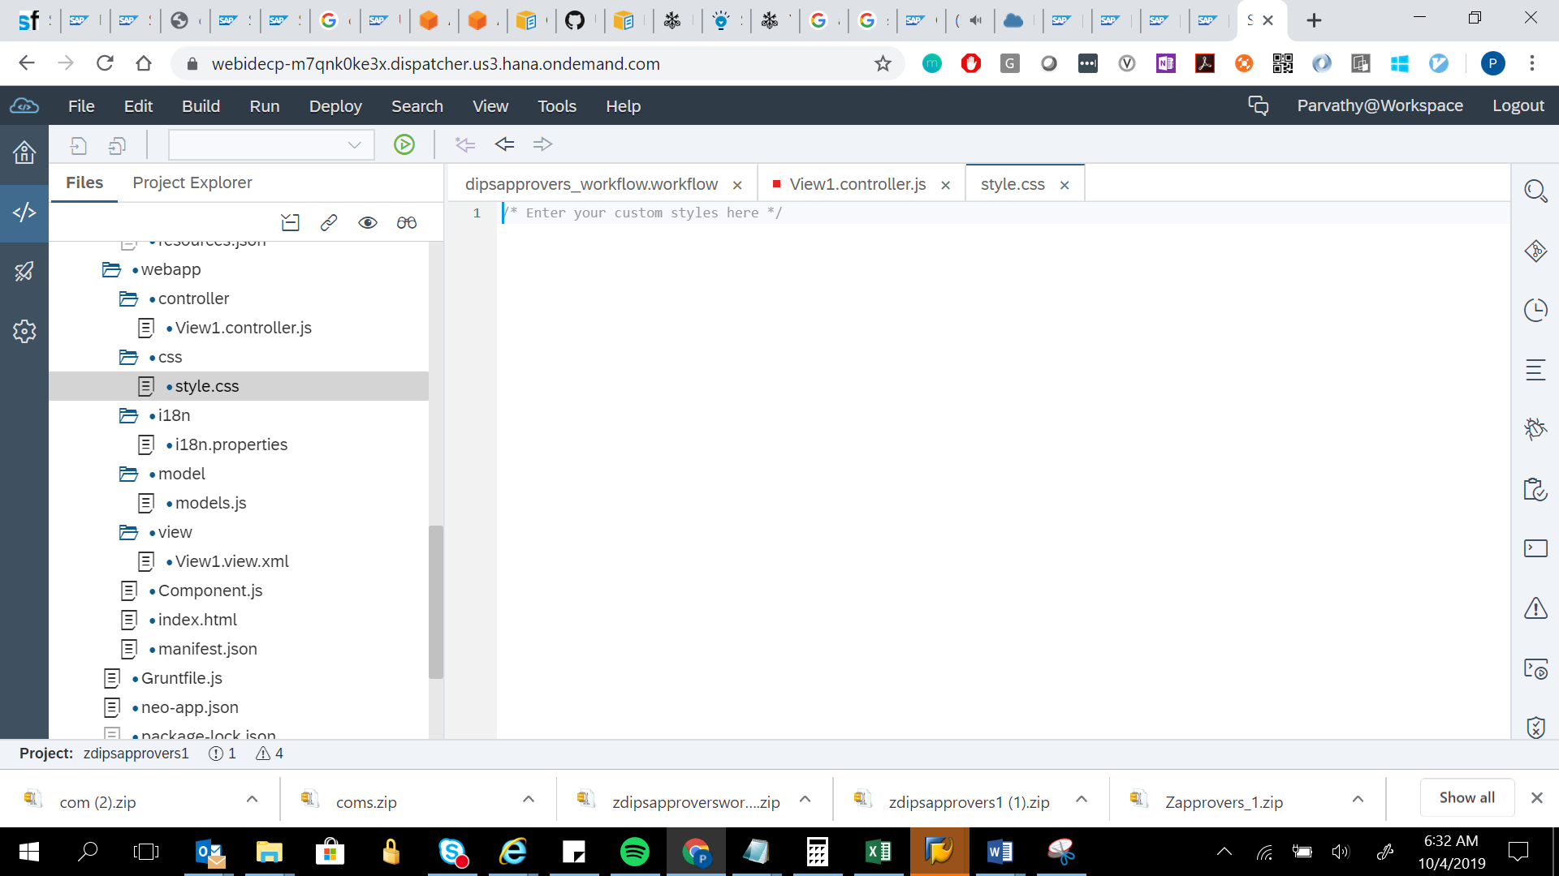

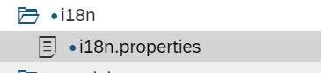

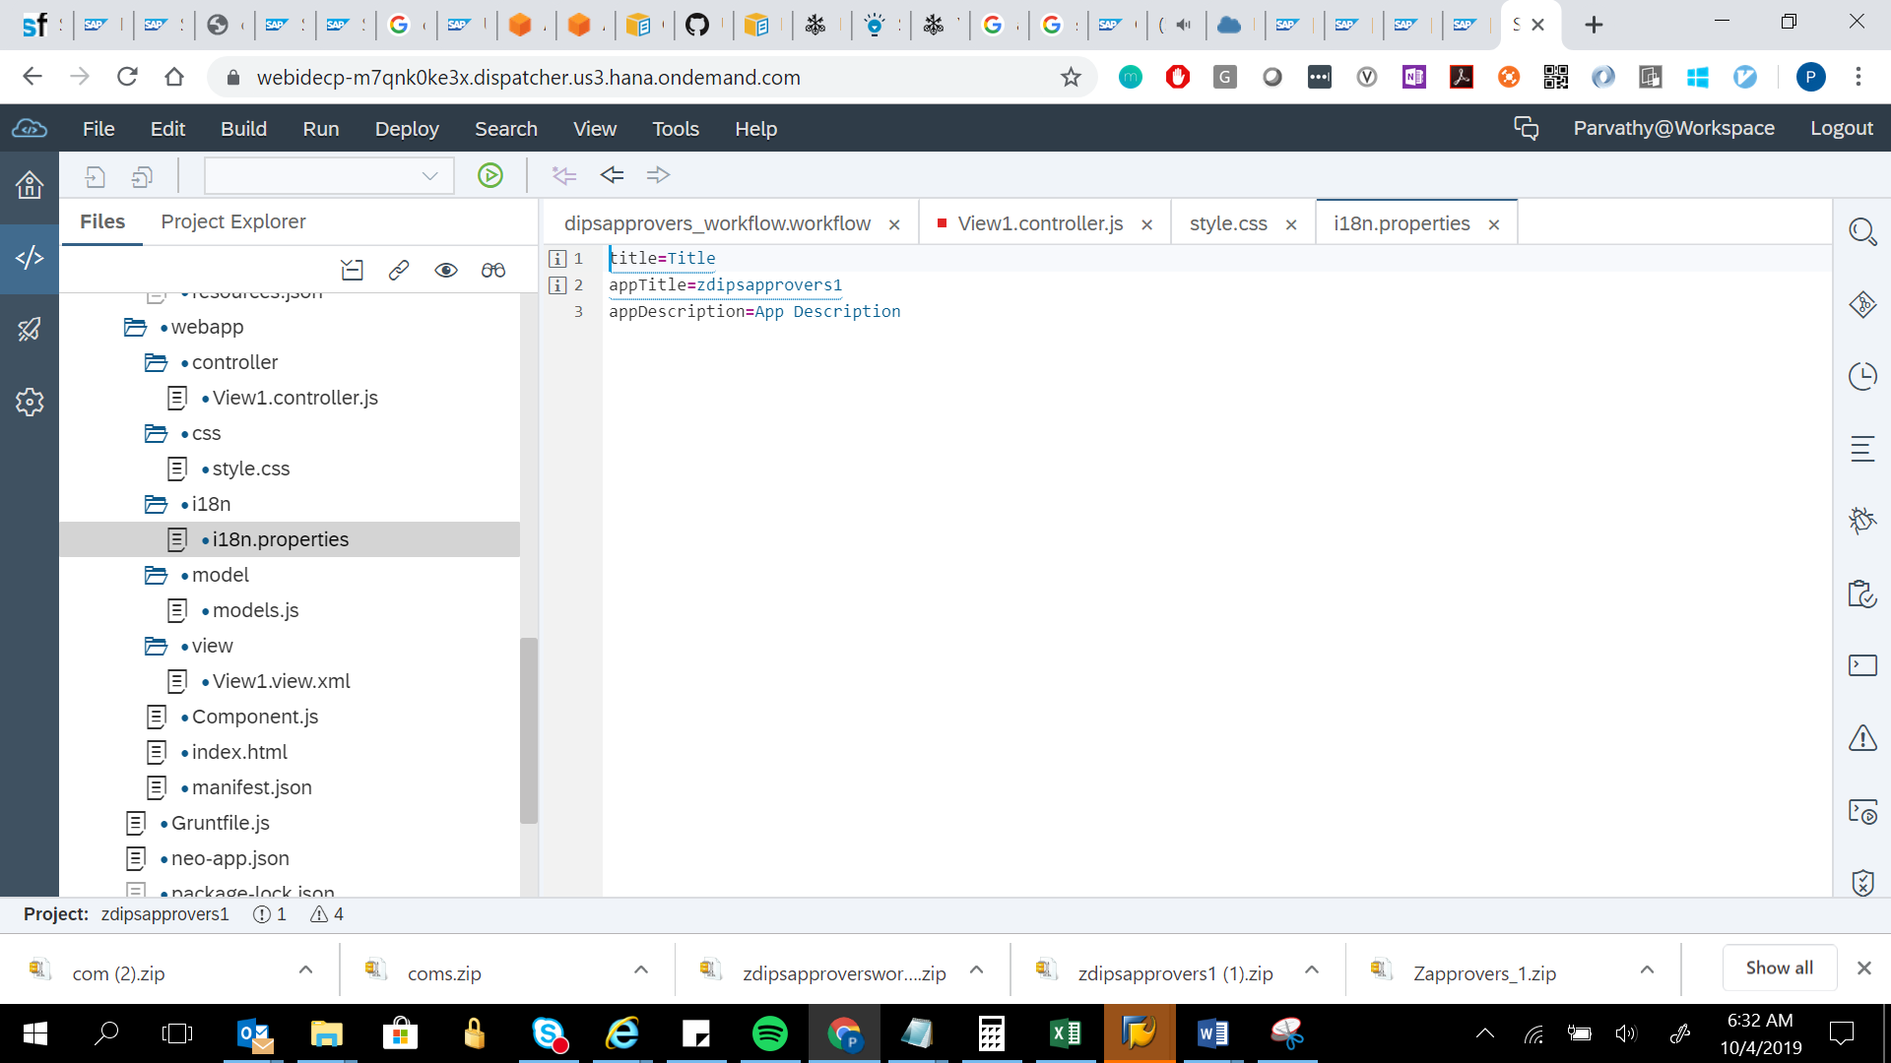

title=Title

appTitle=zdipsapprovers1

appDescription=App Description



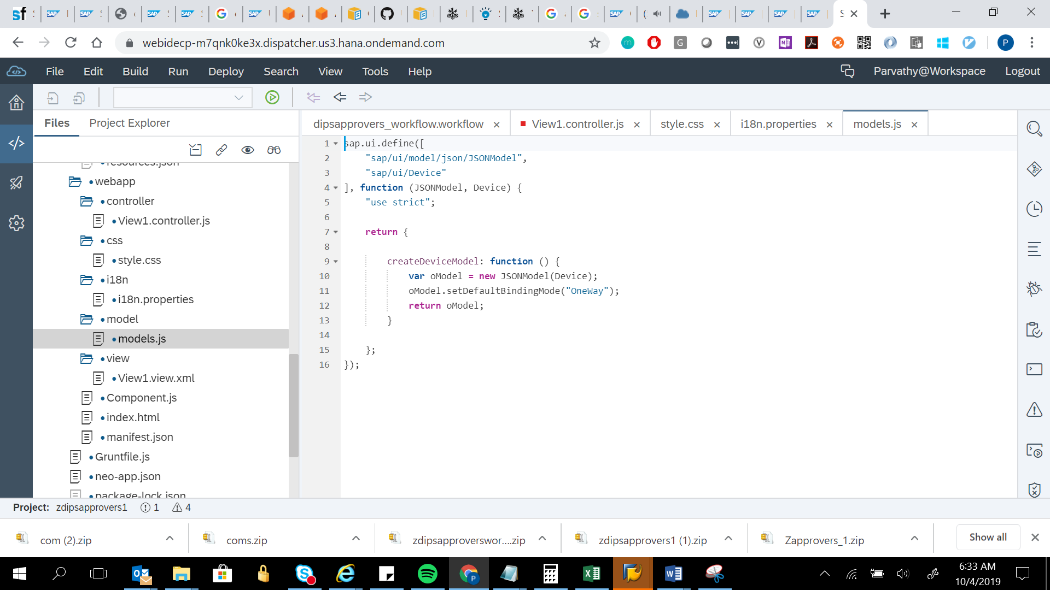

sap.ui.define([

"sap/ui/model/json/JSONModel",

"sap/ui/Device"

], function (JSONModel, Device) {

"use strict";

return {

createDeviceModel: function () {

var oModel = new JSONModel(Device);

oModel.setDefaultBindingMode("OneWay");

return oModel;

}

};

});

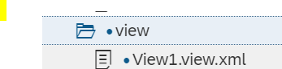

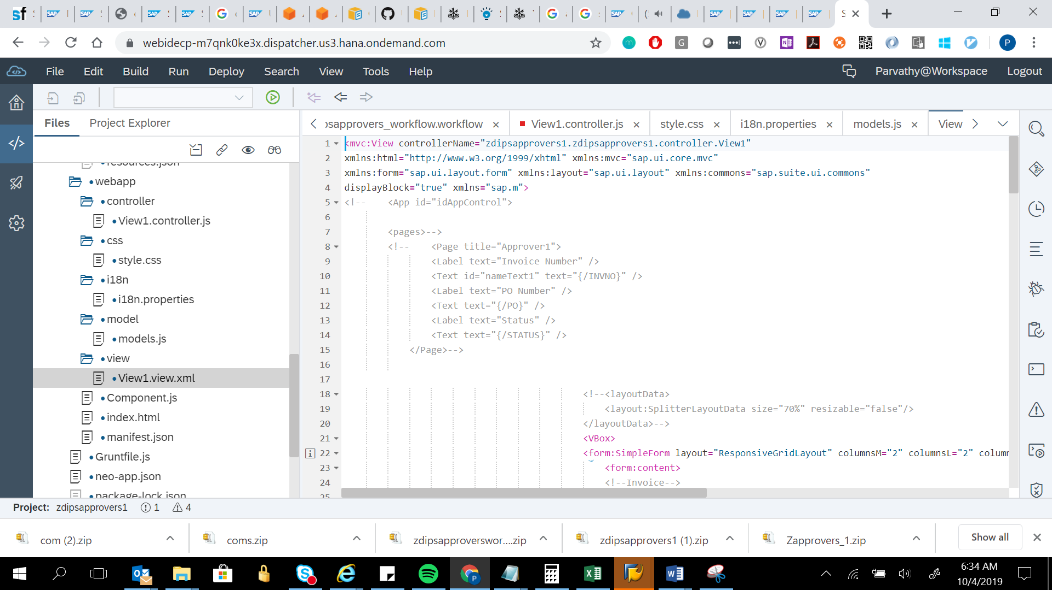

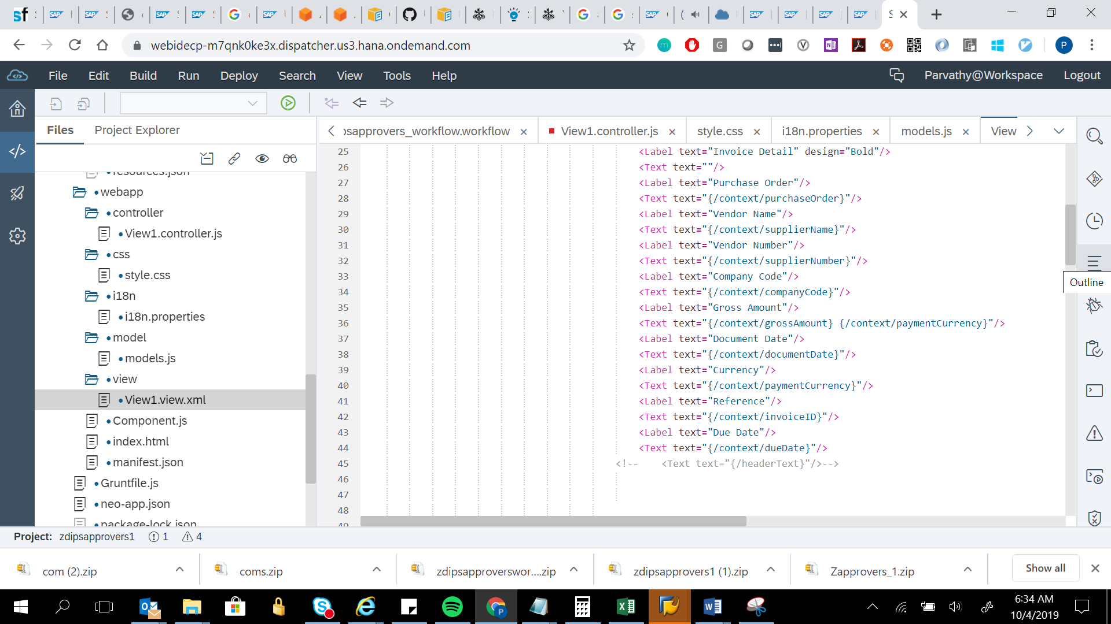

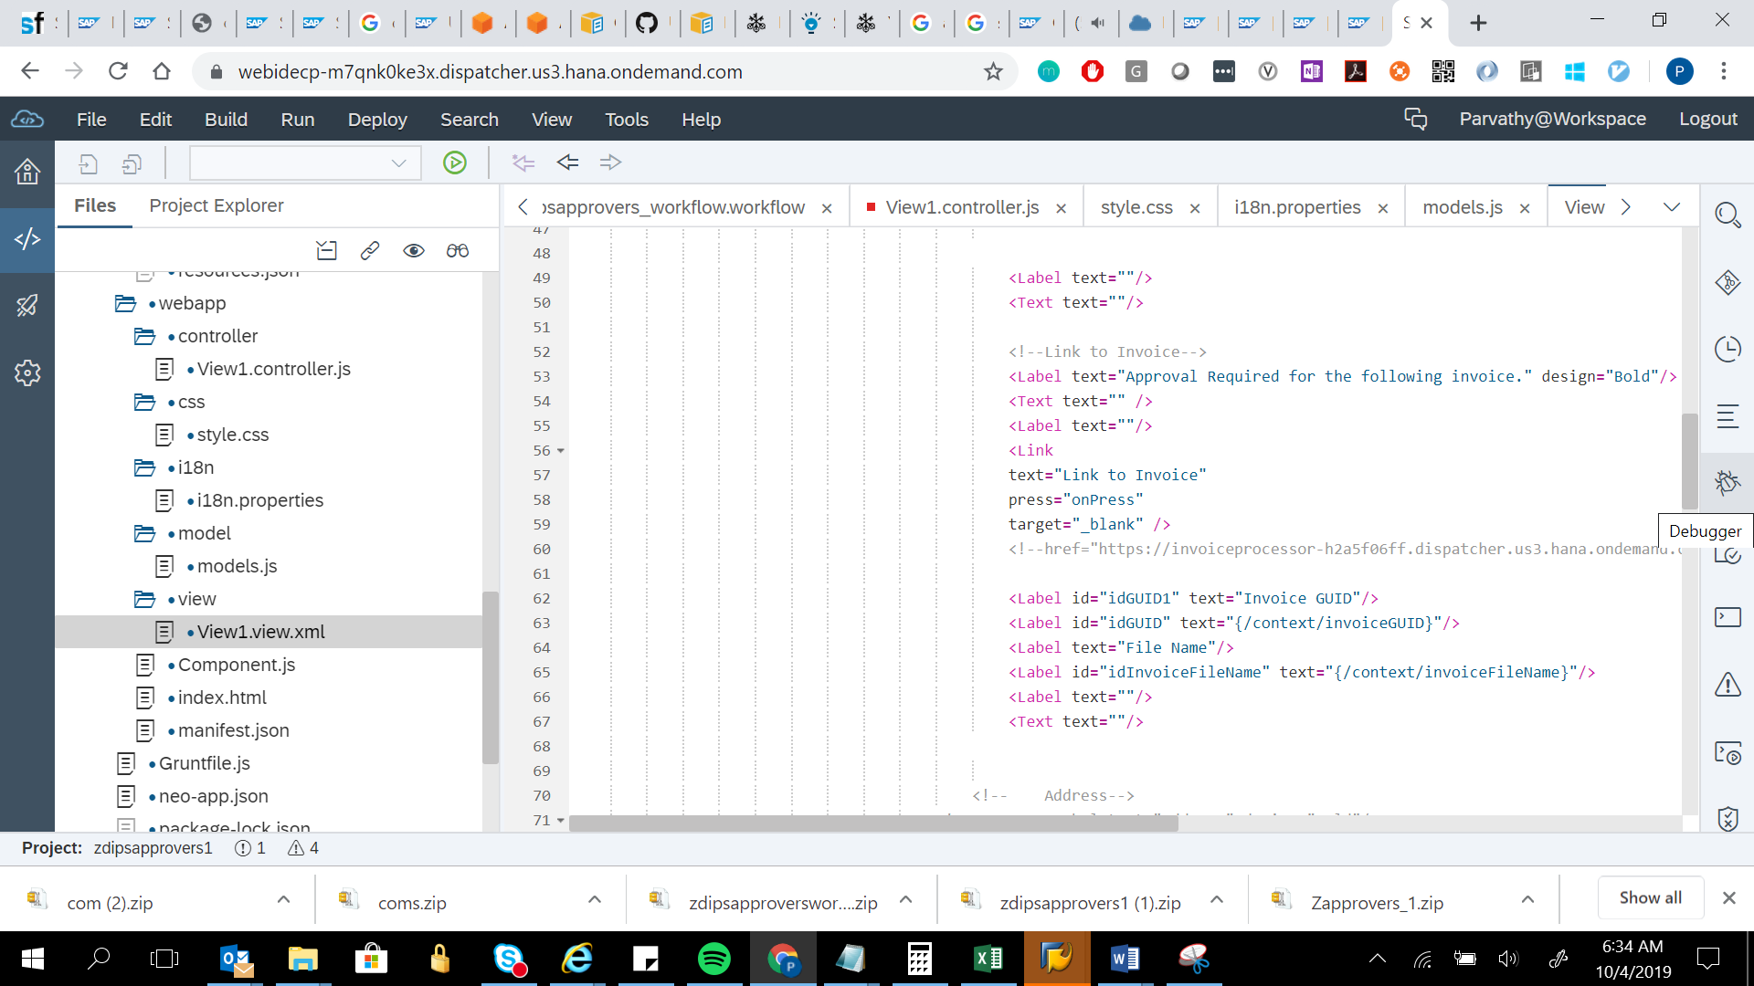

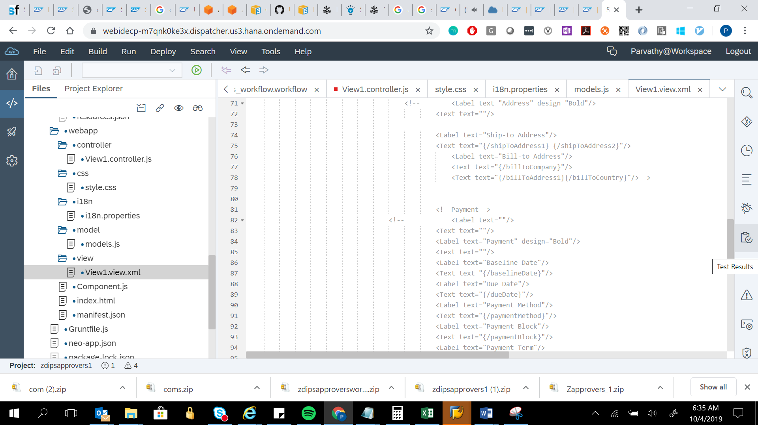

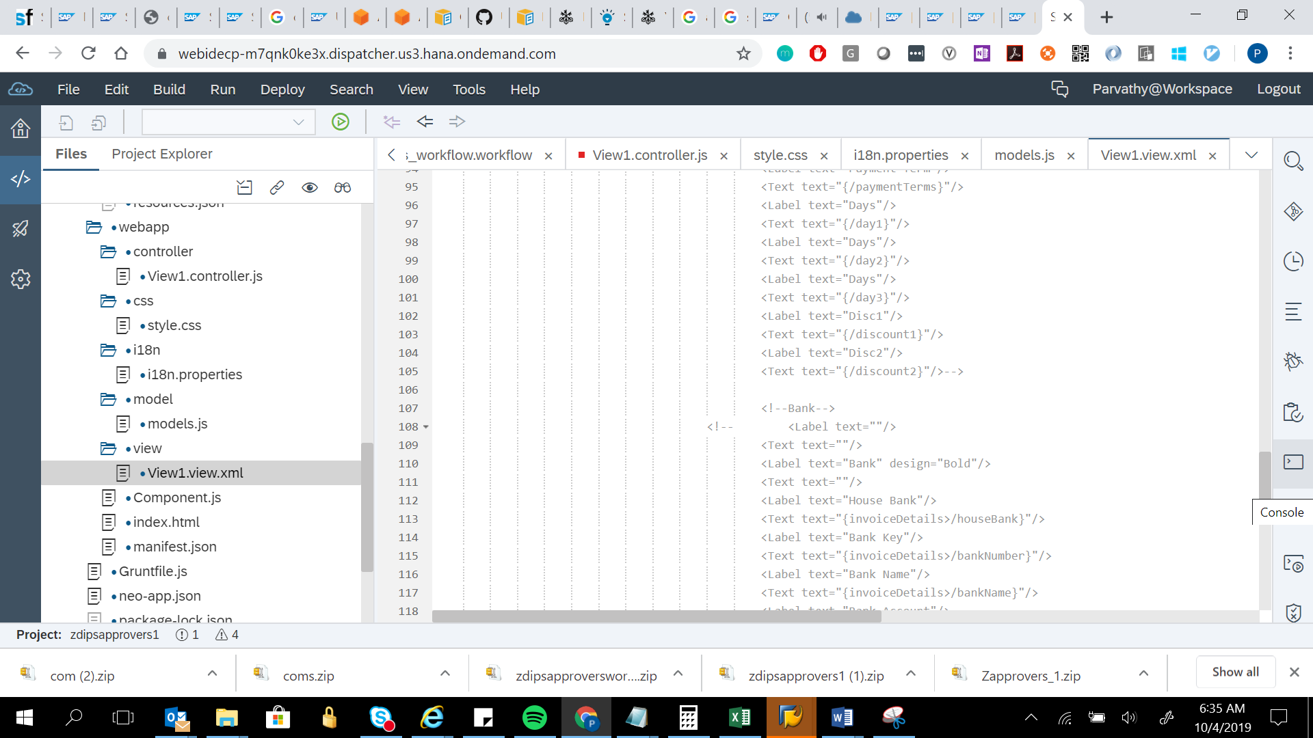

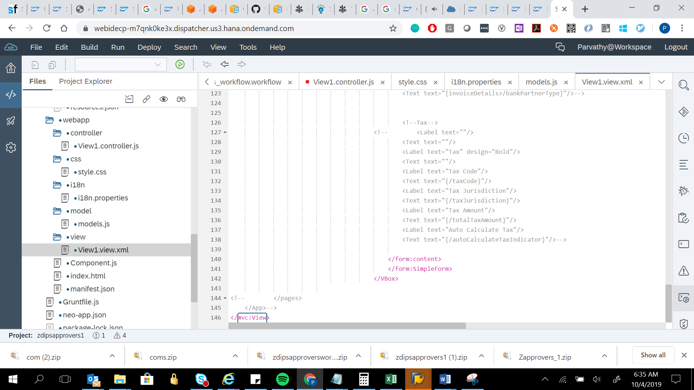

<mvc:View controllerName="zdipsapprovers1.zdipsapprovers1.controller.View1"

xmlns:html="http://www.w3.org/1999/xhtml" xmlns:mvc="sap.ui.core.mvc"

xmlns:form="sap.ui.layout.form" xmlns:layout="sap.ui.layout" xmlns:commons="sap.suite.ui.commons"

displayBlock="true" xmlns="sap.m">

<!-- <App id="idAppControl">

<pages>-->

<!-- <Page title="Approver1">

<Label text="Invoice Number" />

<Text id="nameText1" text="{/INVNO}" />

<Label text="PO Number" />

<Text text="{/PO}" />

<Label text="Status" />

<Text text="{/STATUS}" />

</Page>-->

<!--<layoutData>

<layout:SplitterLayoutData size="70%" resizable="false"/>

</layoutData>-->

<VBox>

<form:SimpleForm layout="ResponsiveGridLayout" columnsM="2" columnsL="2" columnsXL="2">

<form:content>

<!--Invoice-->

<Label text="Invoice Detail" design="Bold"/>

<Text text=""/>

<Label text="Purchase Order"/>

<Text text="{/context/purchaseOrder}"/>

<Label text="Vendor Name"/>

<Text text="{/context/supplierName}"/>

<Label text="Vendor Number"/>

<Text text="{/context/supplierNumber}"/>

<Label text="Company Code"/>

<Text text="{/context/companyCode}"/>

<Label text="Gross Amount"/>

<Text text="{/context/grossAmount} {/context/paymentCurrency}"/>

<Label text="Document Date"/>

<Text text="{/context/documentDate}"/>

<Label text="Currency"/>

<Text text="{/context/paymentCurrency}"/>

<Label text="Reference"/>

<Text text="{/context/invoiceID}"/>

<Label text="Due Date"/>

<Text text="{/context/dueDate}"/>

<!-- <Text text="{/headerText}"/>-->

<Label text=""/>

<Text text=""/>

<!--Link to Invoice-->

<Label text="Approval Required for the following invoice." design="Bold"/>

<Text text="" />

<Label text=""/>

<Link

text="Link to Invoice"

press="onPress"

target="_blank" />

<!--href="https://invoiceprocessor-h2a5f06ff.dispatcher.us3.hana.ondemand.com/index.html?hc_reset#/Invoice/ffffff01ff0500010001c0010001486159e95be95be95be95be95bc1df41ffff" -->

<Label id="idGUID1" text="Invoice GUID"/>

<Label id="idGUID" text="{/context/invoiceGUID}"/>

<Label text="File Name"/>

<Label id="idInvoiceFileName" text="{/context/invoiceFileName}"/>

<Label text=""/>

<Text text=""/>

<!-- Address-->

<!-- <Label text="Address" design="Bold"/>

<Text text=""/>

<Label text="Ship-to Address"/>

<Text text="{/shipToAddress1} {/shipToAddress2}"/>

<Label text="Bill-to Address"/>

<Text text="{/billToCompany}"/>

<Text text="{/billToAddress1}{/billToCountry}"/>-->

<!--Payment-->

<!-- <Label text=""/>

<Text text=""/>

<Label text="Payment" design="Bold"/>

<Text text=""/>

<Label text="Baseline Date"/>

<Text text="{/baselineDate}"/>

<Label text="Due Date"/>

<Text text="{/dueDate}"/>

<Label text="Payment Method"/>

<Text text="{/paymentMethod}"/>

<Label text="Payment Block"/>

<Text text="{/paymentBlock}"/>

<Label text="Payment Term"/>

<Text text="{/paymentTerms}"/>

<Label text="Days"/>

<Text text="{/day1}"/>

<Label text="Days"/>

<Text text="{/day2}"/>

<Label text="Days"/>

<Text text="{/day3}"/>

<Label text="Disc1"/>

<Text text="{/discount1}"/>

<Label text="Disc2"/>

<Text text="{/discount2}"/>-->

<!--Bank-->

<!-- <Label text=""/>

<Text text=""/>

<Label text="Bank" design="Bold"/>

<Text text=""/>

<Label text="House Bank"/>

<Text text="{invoiceDetails>/houseBank}"/>

<Label text="Bank Key"/>

<Text text="{invoiceDetails>/bankNumber}"/>

<Label text="Bank Name"/>

<Text text="{invoiceDetails>/bankName}"/>

<Label text="Bank Account"/>

<Text text="{invoiceDetails>/bankAccount}"/>

<Label text="House Bank A/c ID"/>

<Text text="{invoiceDetails>/houseBankAccountID}"/>

<Label text="Bank Partner Type"/>

<Text text="{invoiceDetails>/bankPartnerType}"/>-->

<!--Tax-->

<!-- <Label text=""/>

<Text text=""/>

<Label text="Tax" design="Bold"/>

<Text text=""/>

<Label text="Tax Code"/>

<Text text="{/taxCode}"/>

<Label text="Tax Jurisdiction"/>

<Text text="{/taxJurisdiction}"/>

<Label text="Tax Amount"/>

<Text text="{/totalTaxAmount}"/>

<Label text="Auto Calculate Tax"/>

<Text text="{/autoCalculateTaxIndicator}"/>-->

</form:content>

</form:SimpleForm>

</VBox>

<!-- </pages>

</App>-->

</mvc:View>



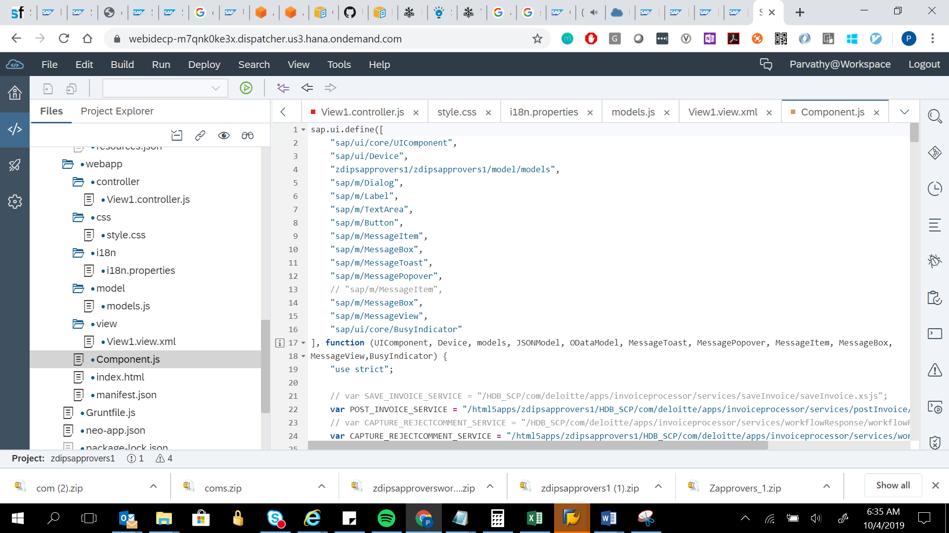

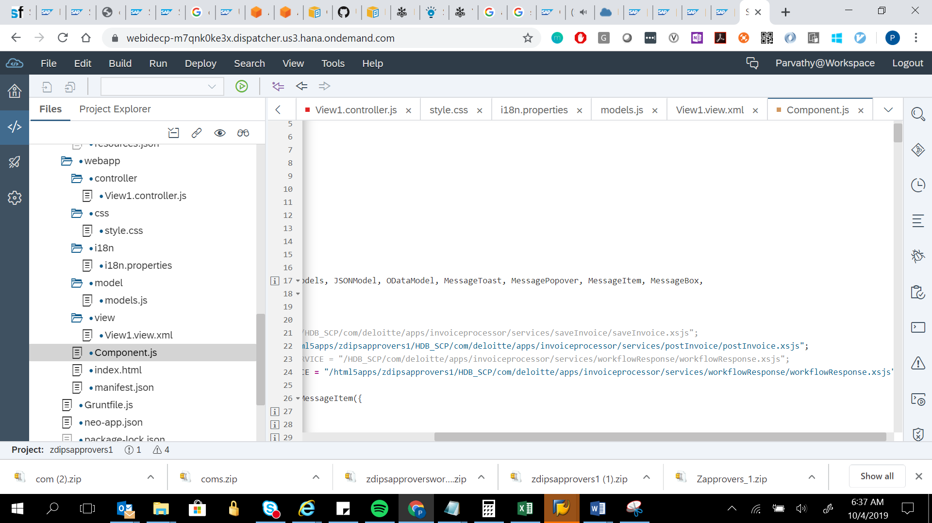

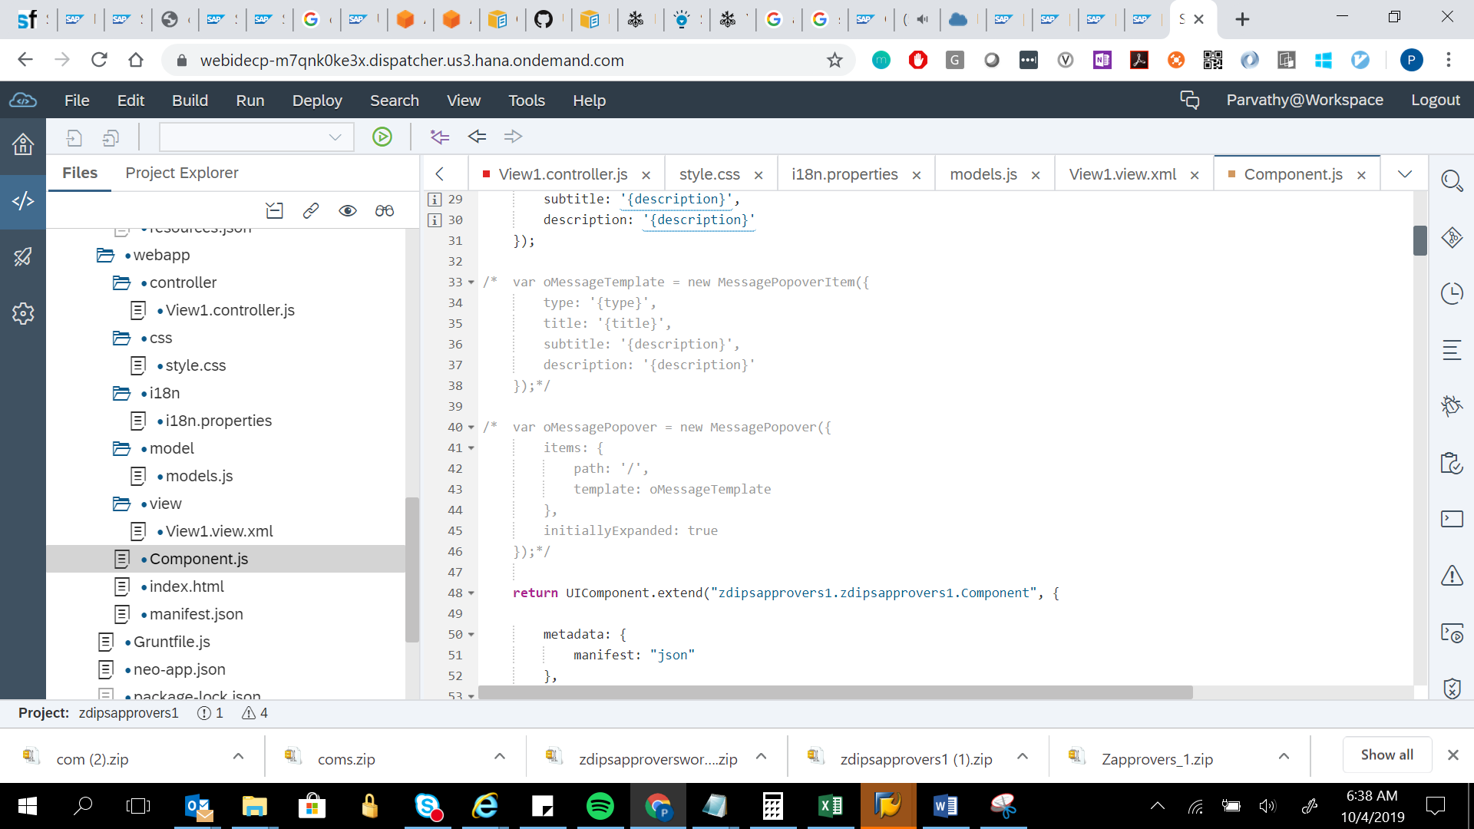

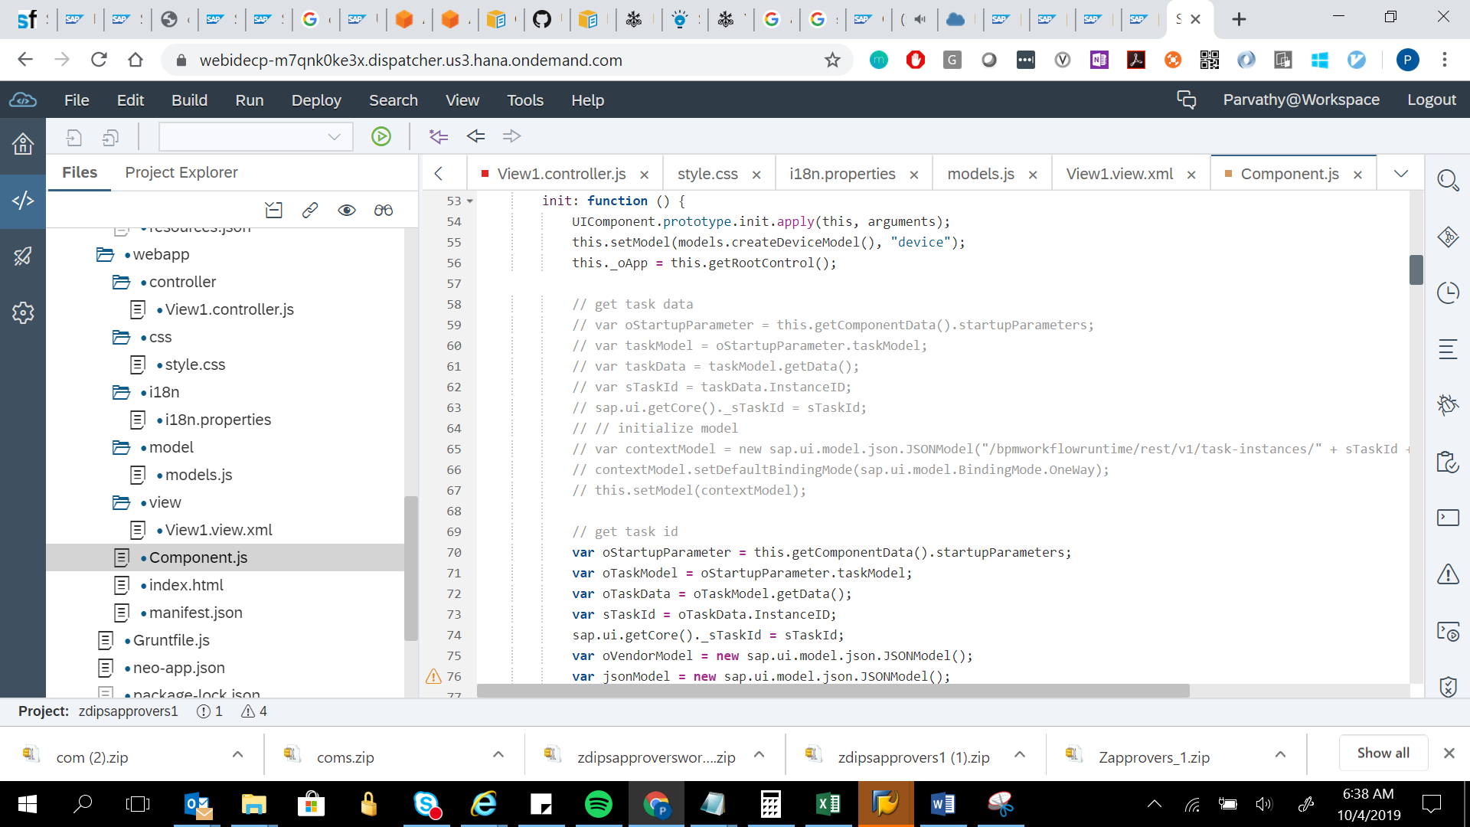

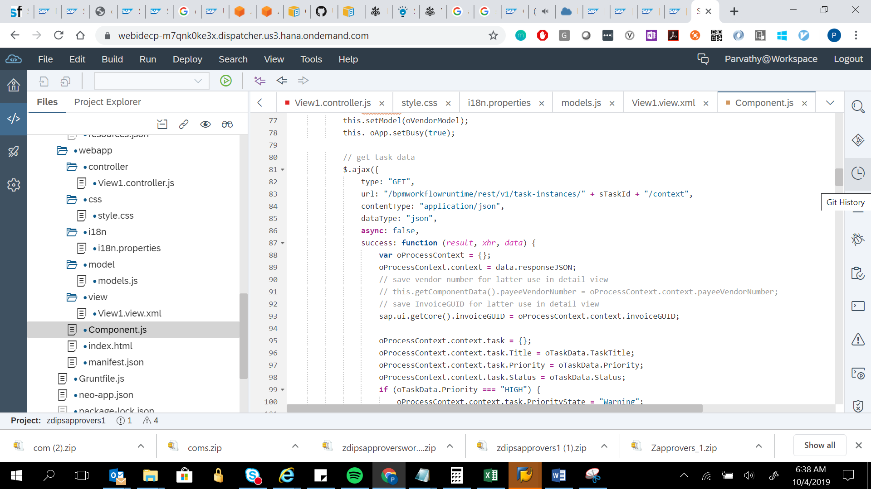

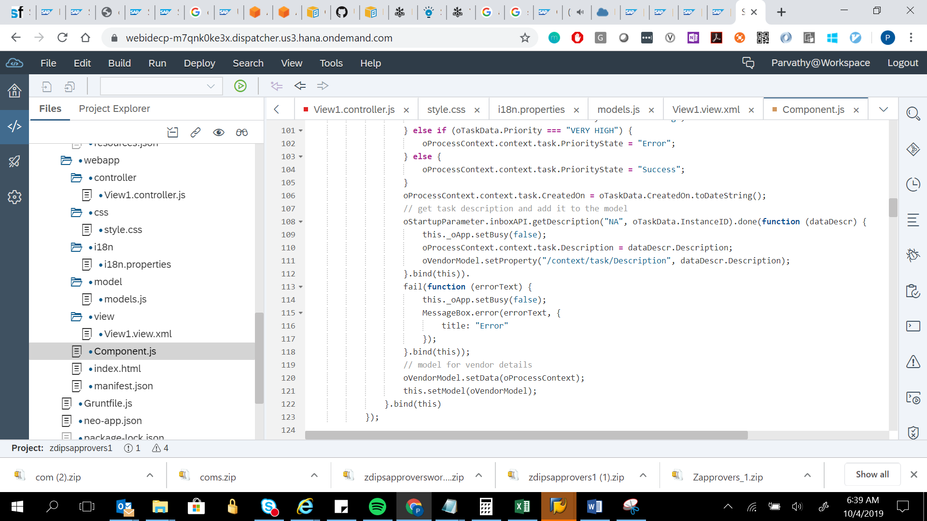

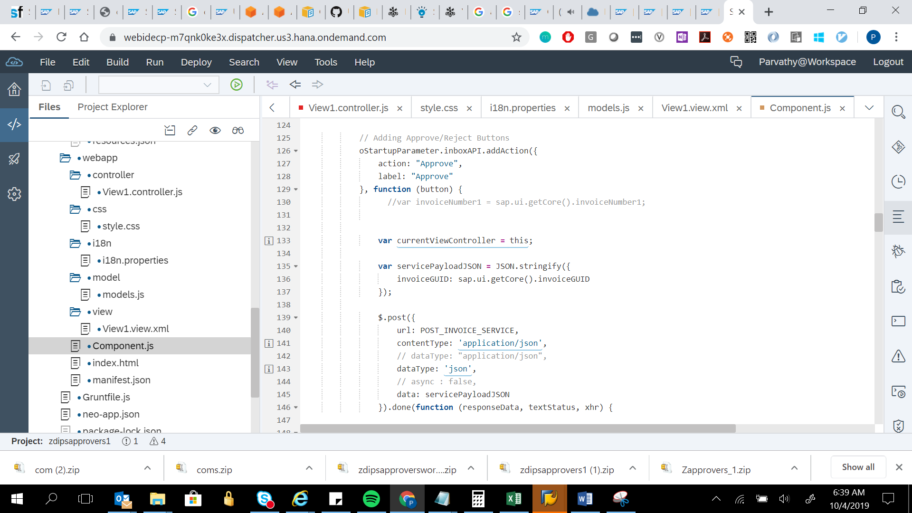

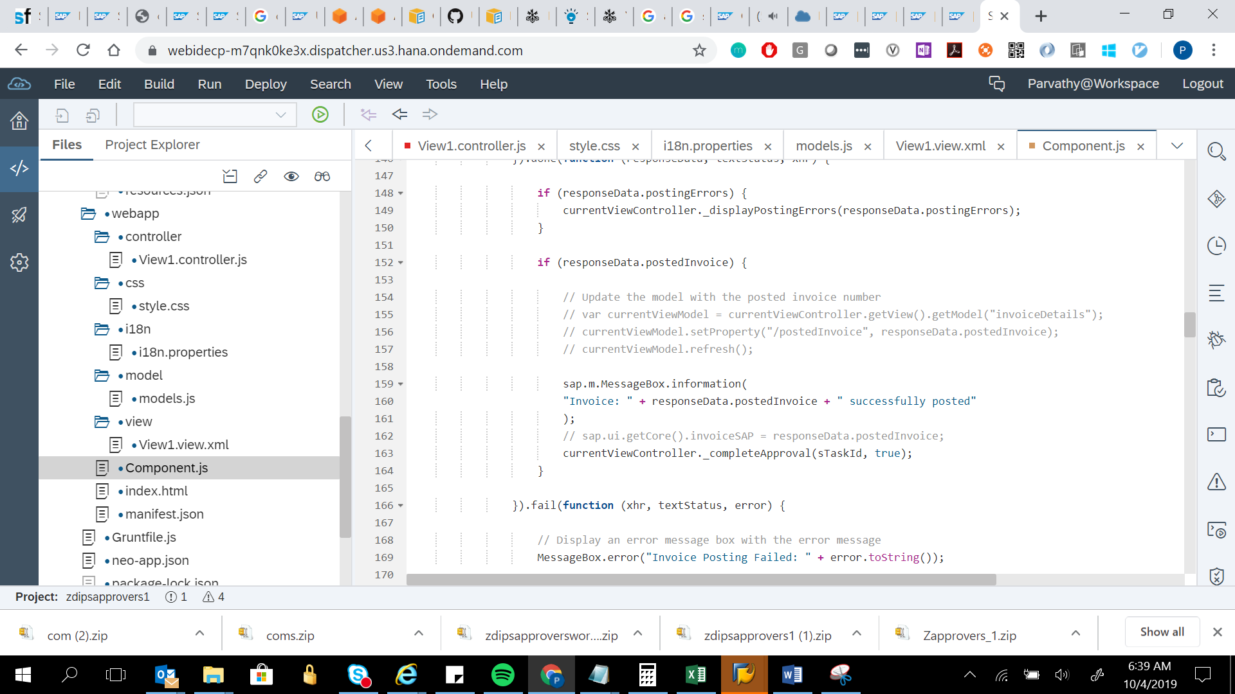

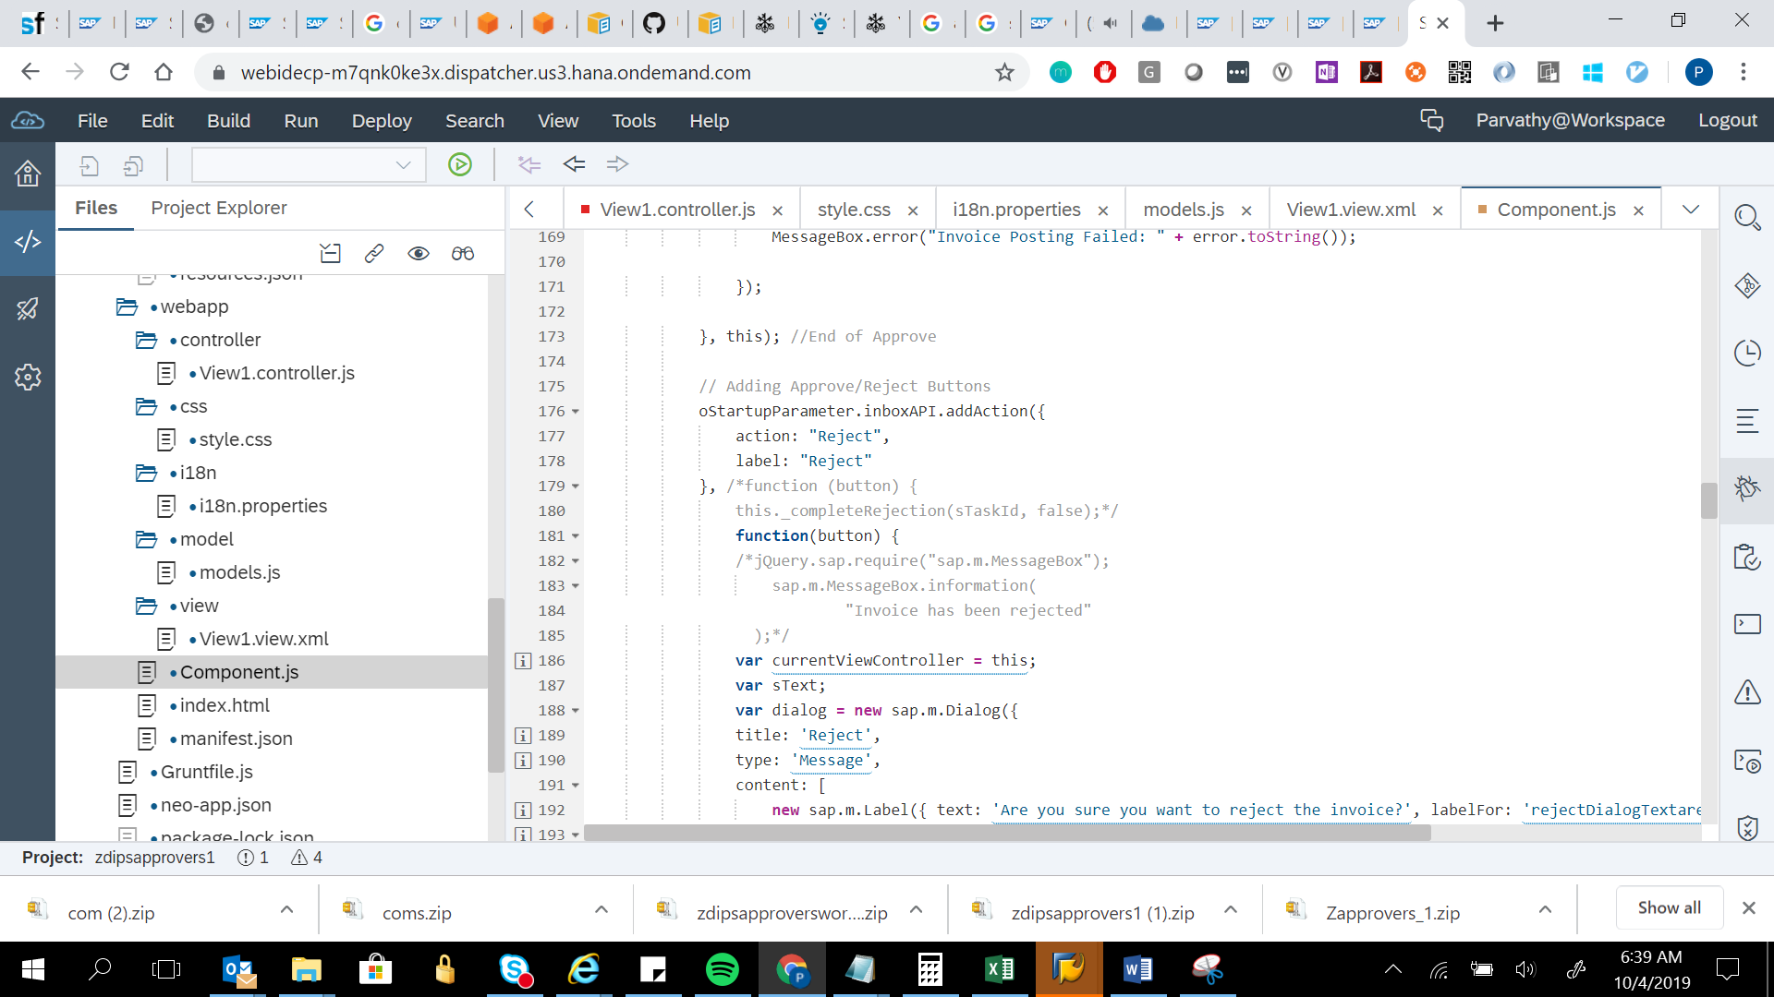

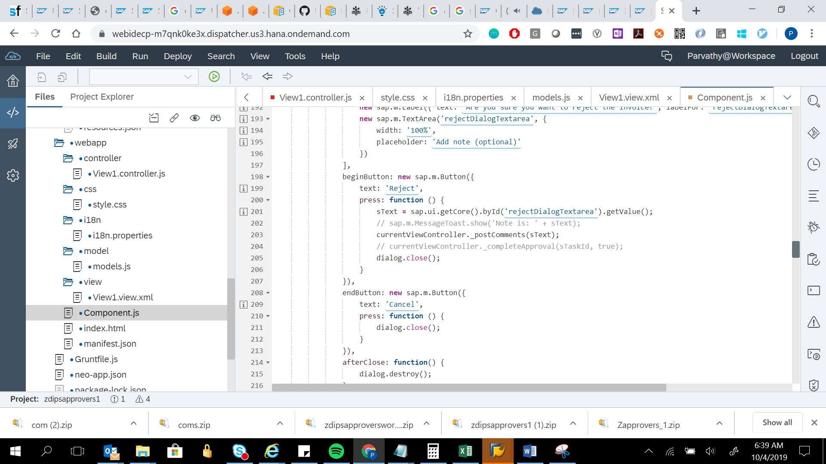

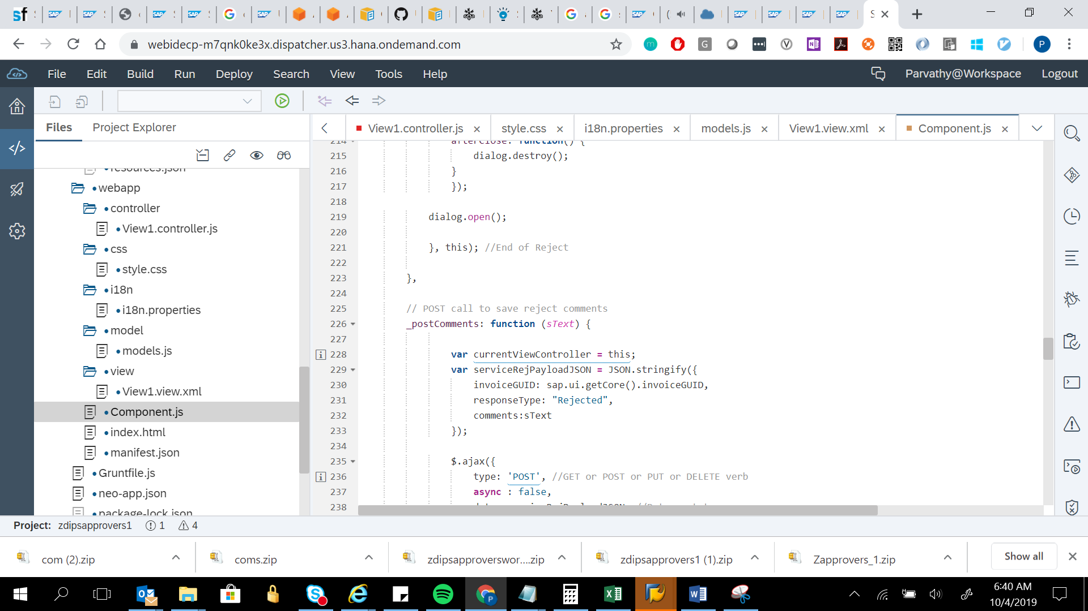

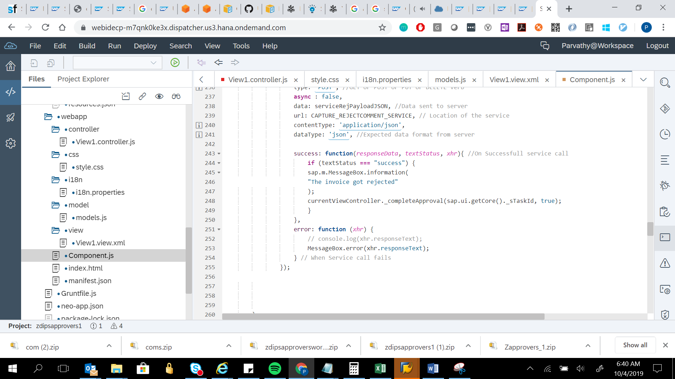

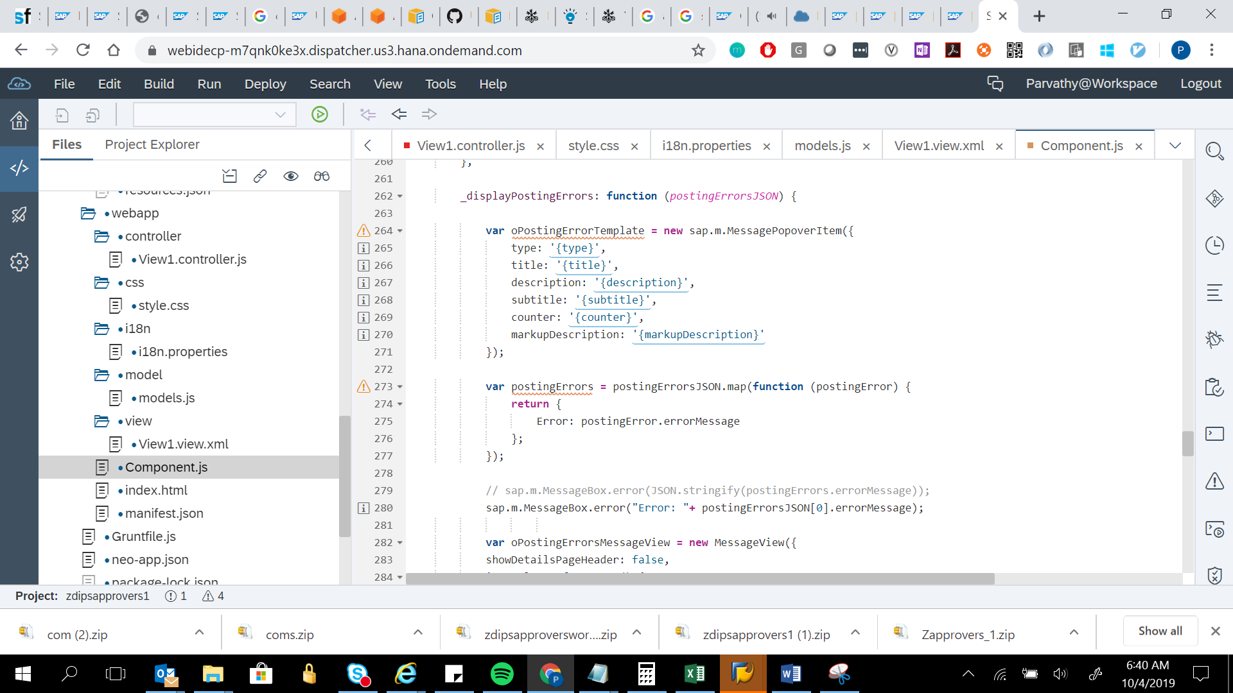

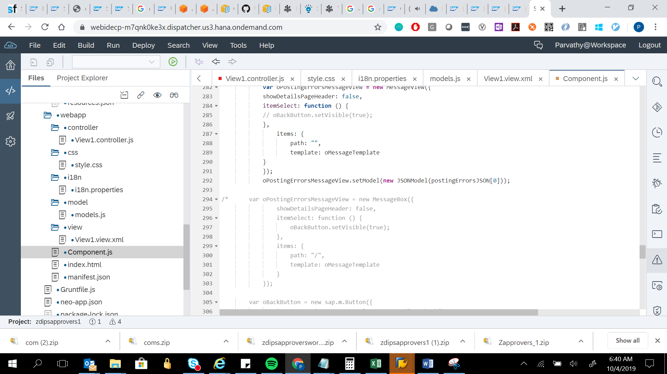

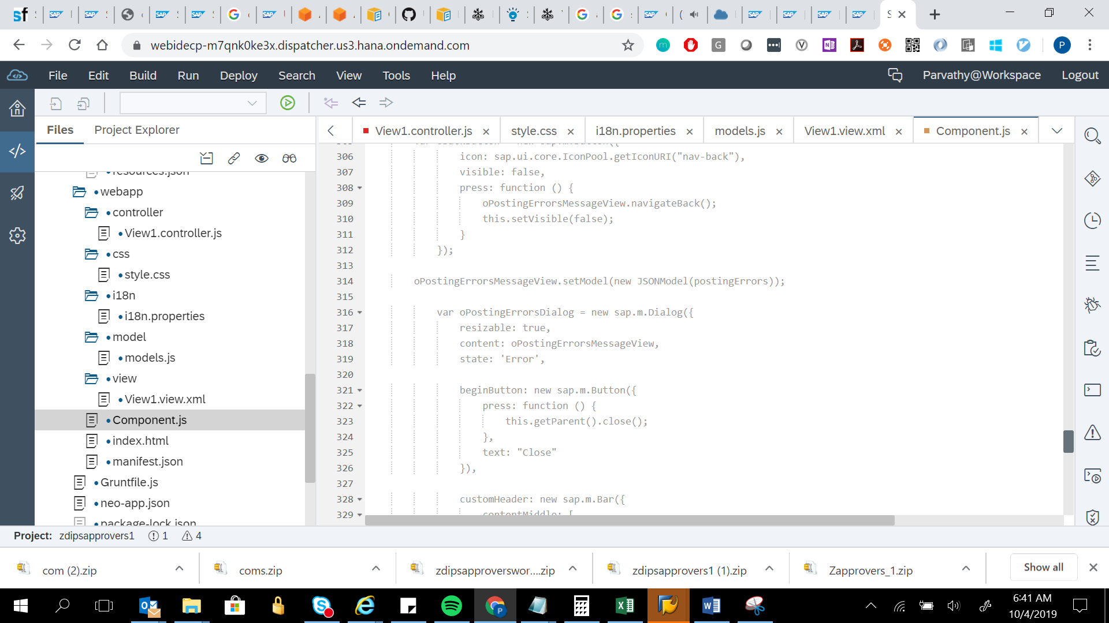

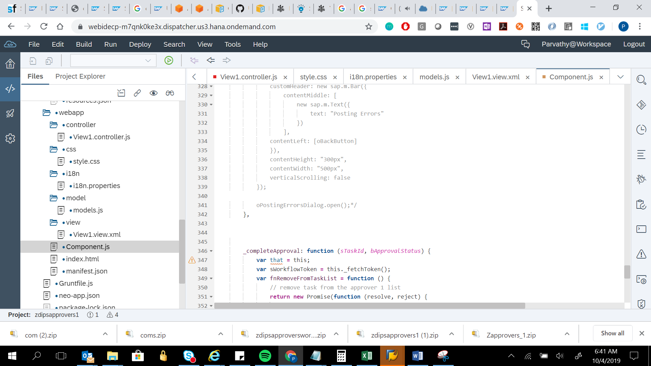

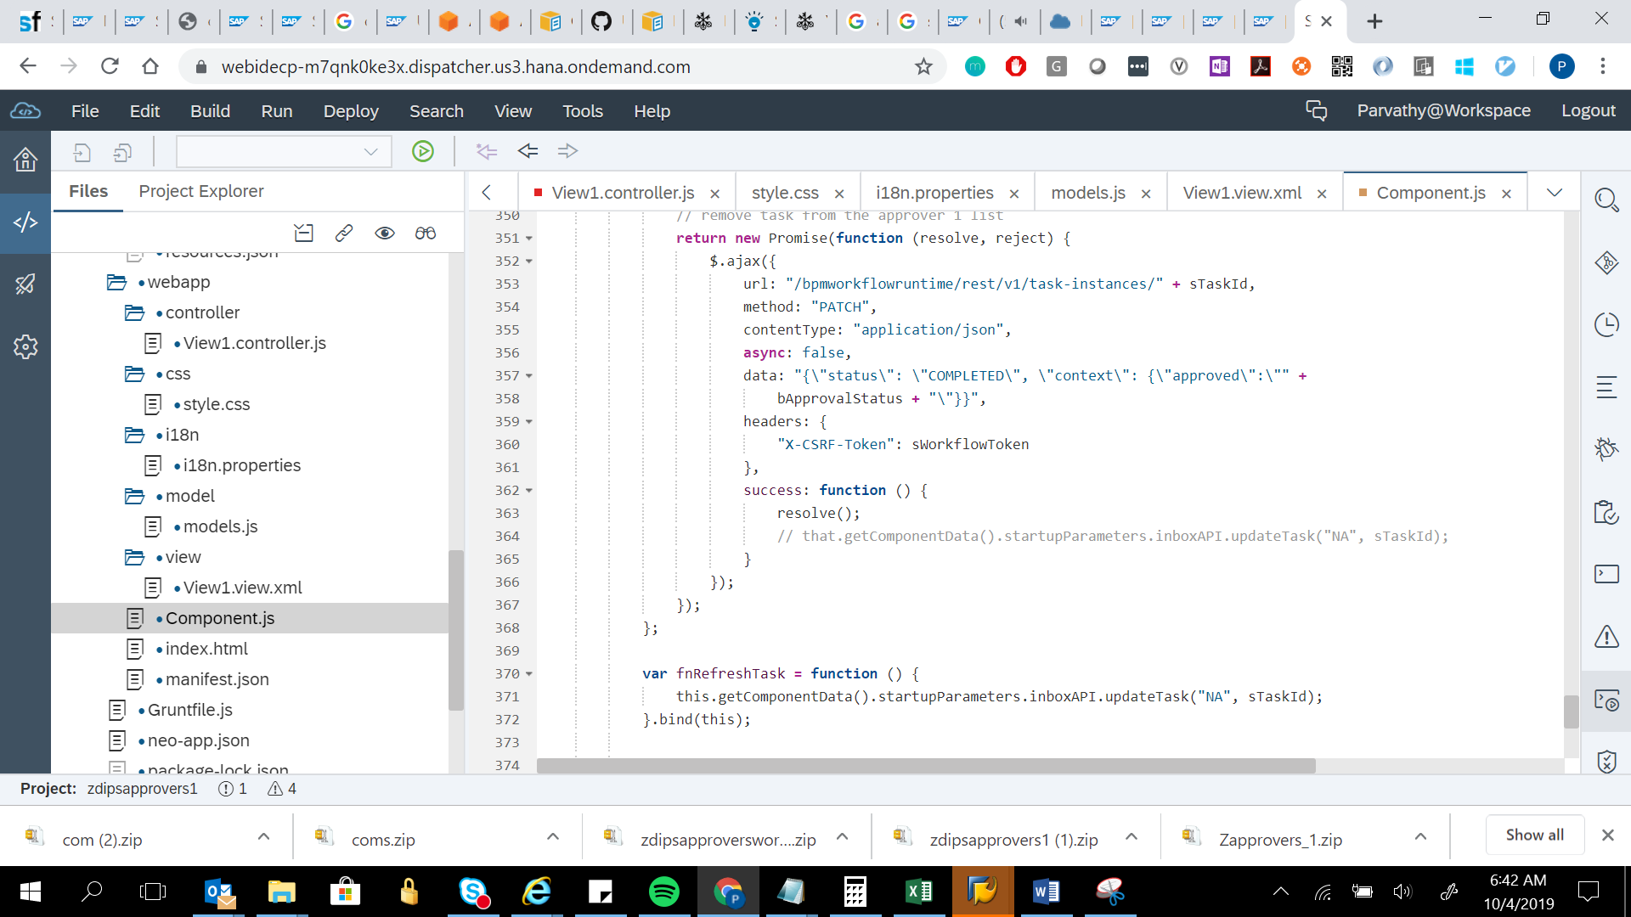

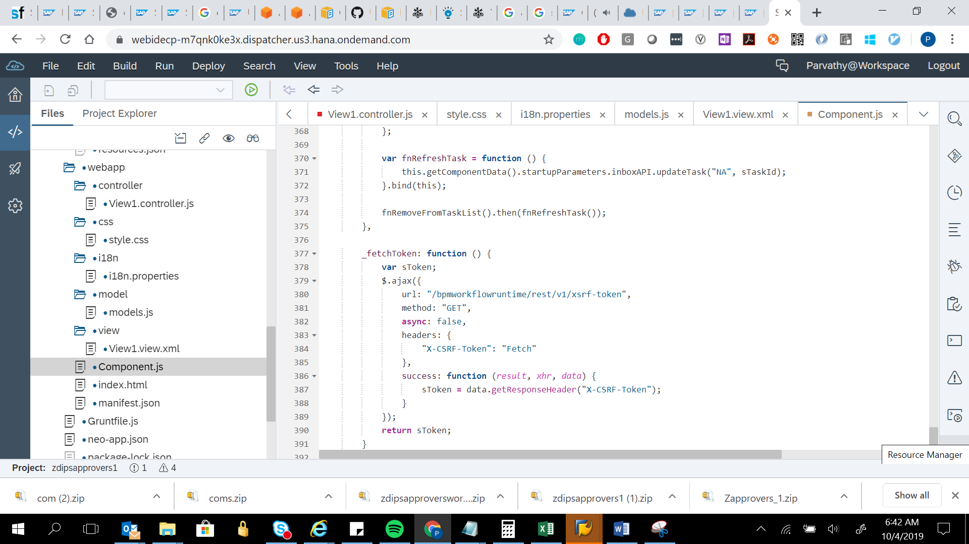

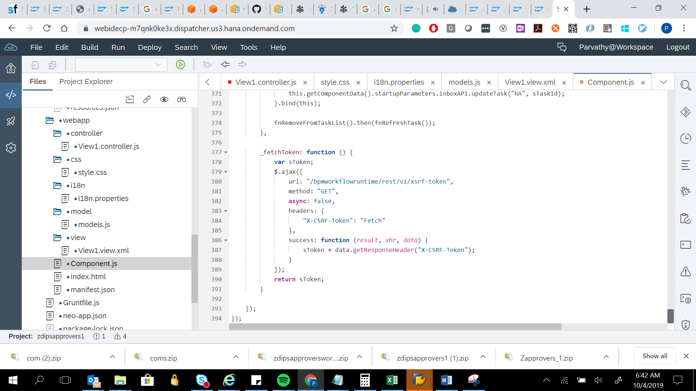

sap.ui.define([

"sap/ui/core/UIComponent",

"sap/ui/Device",

"zdipsapprovers1/zdipsapprovers1/model/models",

"sap/m/Dialog",

"sap/m/Label",

"sap/m/TextArea",

"sap/m/Button",

"sap/m/MessageItem",

"sap/m/MessageBox",

"sap/m/MessageToast",

"sap/m/MessagePopover",

// "sap/m/MessageItem",

"sap/m/MessageBox",

"sap/m/MessageView",

"sap/ui/core/BusyIndicator"

], function (UIComponent, Device, models, JSONModel, ODataModel, MessageToast, MessagePopover, MessageItem, MessageBox,

MessageView,BusyIndicator) {

"use strict";

// var SAVE_INVOICE_SERVICE = "/HDB_SCP/com/deloitte/apps/invoiceprocessor/services/saveInvoice/saveInvoice.xsjs";

var POST_INVOICE_SERVICE = "/html5apps/zdipsapprovers1/HDB_SCP/com/deloitte/apps/invoiceprocessor/services/postInvoice/postInvoice.xsjs";

// var CAPTURE_REJECTCOMMENT_SERVICE = "/HDB_SCP/com/deloitte/apps/invoiceprocessor/services/workflowResponse/workflowResponse.xsjs";

var CAPTURE_REJECTCOMMENT_SERVICE = "/html5apps/zdipsapprovers1/HDB_SCP/com/deloitte/apps/invoiceprocessor/services/workflowResponse/workflowResponse.xsjs";

var oMessageTemplate = new MessageItem({

type: '{type}',

title: '{title}',

subtitle: '{description}',

description: '{description}'

});

/* var oMessageTemplate = new MessagePopoverItem({

type: '{type}',

title: '{title}',

subtitle: '{description}',

description: '{description}'

});*/

/* var oMessagePopover = new MessagePopover({

items: {

path: '/',

template: oMessageTemplate

},

initiallyExpanded: true

});*/

return UIComponent.extend("zdipsapprovers1.zdipsapprovers1.Component", {

metadata: {

manifest: "json"

},

init: function () {

UIComponent.prototype.init.apply(this, arguments);

this.setModel(models.createDeviceModel(), "device");

this._oApp = this.getRootControl();

// get task data

// var oStartupParameter = this.getComponentData().startupParameters;

// var taskModel = oStartupParameter.taskModel;

// var taskData = taskModel.getData();

// var sTaskId = taskData.InstanceID;

// sap.ui.getCore()._sTaskId = sTaskId;

// // initialize model

// var contextModel = new sap.ui.model.json.JSONModel("/bpmworkflowruntime/rest/v1/task-instances/" + sTaskId + "/context");

// contextModel.setDefaultBindingMode(sap.ui.model.BindingMode.OneWay);

// this.setModel(contextModel);

// get task id

var oStartupParameter = this.getComponentData().startupParameters;

var oTaskModel = oStartupParameter.taskModel;

var oTaskData = oTaskModel.getData();

var sTaskId = oTaskData.InstanceID;

sap.ui.getCore()._sTaskId = sTaskId;

var oVendorModel = new sap.ui.model.json.JSONModel();

var jsonModel = new sap.ui.model.json.JSONModel();

this.setModel(oVendorModel);

this._oApp.setBusy(true);

// get task data

$.ajax({

type: "GET",

url: "/bpmworkflowruntime/rest/v1/task-instances/" + sTaskId + "/context",

contentType: "application/json",

dataType: "json",

async: false,

success: function (result, xhr, data) {

var oProcessContext = {};

oProcessContext.context = data.responseJSON;

// save vendor number for latter use in detail view

// this.getComponentData().payeeVendorNumber = oProcessContext.context.payeeVendorNumber;

// save InvoiceGUID for latter use in detail view

sap.ui.getCore().invoiceGUID = oProcessContext.context.invoiceGUID;

oProcessContext.context.task = {};

oProcessContext.context.task.Title = oTaskData.TaskTitle;

oProcessContext.context.task.Priority = oTaskData.Priority;

oProcessContext.context.task.Status = oTaskData.Status;

if (oTaskData.Priority === "HIGH") {

oProcessContext.context.task.PriorityState = "Warning";

} else if (oTaskData.Priority === "VERY HIGH") {

oProcessContext.context.task.PriorityState = "Error";

} else {

oProcessContext.context.task.PriorityState = "Success";

}

oProcessContext.context.task.CreatedOn = oTaskData.CreatedOn.toDateString();

// get task description and add it to the model

oStartupParameter.inboxAPI.getDescription("NA", oTaskData.InstanceID).done(function (dataDescr) {

this._oApp.setBusy(false);

oProcessContext.context.task.Description = dataDescr.Description;

oVendorModel.setProperty("/context/task/Description", dataDescr.Description);

}.bind(this)).

fail(function (errorText) {

this._oApp.setBusy(false);

MessageBox.error(errorText, {

title: "Error"

});

}.bind(this));

// model for vendor details

oVendorModel.setData(oProcessContext);

this.setModel(oVendorModel);

}.bind(this)

});

// Adding Approve/Reject Buttons

oStartupParameter.inboxAPI.addAction({

action: "Approve",

label: "Approve"

}, function (button) {

//var invoiceNumber1 = sap.ui.getCore().invoiceNumber1;

var currentViewController = this;

var servicePayloadJSON = JSON.stringify({

invoiceGUID: sap.ui.getCore().invoiceGUID

});

$.post({

url: POST_INVOICE_SERVICE,

contentType: 'application/json',

// dataType: "application/json",

dataType: 'json',

// async : false,

data: servicePayloadJSON

}).done(function (responseData, textStatus, xhr) {

if (responseData.postingErrors) {

currentViewController._displayPostingErrors(responseData.postingErrors);

}

if (responseData.postedInvoice) {

// Update the model with the posted invoice number

// var currentViewModel = currentViewController.getView().getModel("invoiceDetails");

// currentViewModel.setProperty("/postedInvoice", responseData.postedInvoice);

// currentViewModel.refresh();

sap.m.MessageBox.information(

"Invoice: " + responseData.postedInvoice + " successfully posted"

);

// sap.ui.getCore().invoiceSAP = responseData.postedInvoice;

currentViewController._completeApproval(sTaskId, true);

}

}).fail(function (xhr, textStatus, error) {

// Display an error message box with the error message

MessageBox.error("Invoice Posting Failed: " + error.toString());

});

}, this); //End of Approve

// Adding Approve/Reject Buttons

oStartupParameter.inboxAPI.addAction({

action: "Reject",

label: "Reject"

}, /*function (button) {

this._completeRejection(sTaskId, false);*/

function(button) {

/*jQuery.sap.require("sap.m.MessageBox");

sap.m.MessageBox.information(

"Invoice has been rejected"

);*/

var currentViewController = this;

var sText;

var dialog = new sap.m.Dialog({

title: 'Reject',

type: 'Message',

content: [

new sap.m.Label({ text: 'Are you sure you want to reject the invoice?', labelFor: 'rejectDialogTextarea'}),

new sap.m.TextArea('rejectDialogTextarea', {

width: '100%',

placeholder: 'Add note (optional)'

})

],

beginButton: new sap.m.Button({

text: 'Reject',

press: function () {

sText = sap.ui.getCore().byId('rejectDialogTextarea').getValue();

// sap.m.MessageToast.show('Note is: ' + sText);

currentViewController._postComments(sText);

// currentViewController._completeApproval(sTaskId, true);

dialog.close();

}

}),

endButton: new sap.m.Button({

text: 'Cancel',

press: function () {

dialog.close();

}

}),

afterClose: function() {

dialog.destroy();

}

});

dialog.open();

}, this); //End of Reject

},

// POST call to save reject comments

_postComments: function (sText) {

var currentViewController = this;

var serviceRejPayloadJSON = JSON.stringify({

invoiceGUID: sap.ui.getCore().invoiceGUID,

responseType: "Rejected",

comments:sText

});

$.ajax({

type: 'POST', //GET or POST or PUT or DELETE verb

async : false,

data: serviceRejPayloadJSON, //Data sent to server

url: CAPTURE_REJECTCOMMENT_SERVICE, // Location of the service

contentType: 'application/json',

dataType: 'json', //Expected data format from server

success: function(responseData, textStatus, xhr){ //On Successfull service call

if (textStatus === "success") {

sap.m.MessageBox.information(

"The invoice got rejected"

);

currentViewController._completeApproval(sap.ui.getCore()._sTaskId, true);

}

},

error: function (xhr) {

// console.log(xhr.responseText);

MessageBox.error(xhr.responseText);

} // When Service call fails

});

},

_displayPostingErrors: function (postingErrorsJSON) {

var oPostingErrorTemplate = new sap.m.MessagePopoverItem({

type: '{type}',

title: '{title}',

description: '{description}',

subtitle: '{subtitle}',

counter: '{counter}',

markupDescription: '{markupDescription}'

});

var postingErrors = postingErrorsJSON.map(function (postingError) {

return {

Error: postingError.errorMessage

};

});

// sap.m.MessageBox.error(JSON.stringify(postingErrors.errorMessage));

sap.m.MessageBox.error("Error: "+ postingErrorsJSON[0].errorMessage);

var oPostingErrorsMessageView = new MessageView({

showDetailsPageHeader: false,

itemSelect: function () {

// oBackButton.setVisible(true);

},

items: {

path: "",

template: oMessageTemplate

}

});

oPostingErrorsMessageView.setModel(new JSONModel(postingErrorsJSON[0]));

/* var oPostingErrorsMessageView = new MessageBox({

showDetailsPageHeader: false,

itemSelect: function () {

oBackButton.setVisible(true);

},

items: {

path: "/",

template: oMessageTemplate

}

});

var oBackButton = new sap.m.Button({

icon: sap.ui.core.IconPool.getIconURI("nav-back"),

visible: false,

press: function () {

oPostingErrorsMessageView.navigateBack();

this.setVisible(false);

}

});

oPostingErrorsMessageView.setModel(new JSONModel(postingErrors));

var oPostingErrorsDialog = new sap.m.Dialog({

resizable: true,

content: oPostingErrorsMessageView,

state: 'Error',

beginButton: new sap.m.Button({

press: function () {

this.getParent().close();

},

text: "Close"

}),

customHeader: new sap.m.Bar({

contentMiddle: [

new sap.m.Text({

text: "Posting Errors"

})

],

contentLeft: [oBackButton]

}),

contentHeight: "300px",

contentWidth: "500px",

verticalScrolling: false

});

oPostingErrorsDialog.open();*/

},

_completeApproval: function (sTaskId, bApprovalStatus) {

var that = this;

var sWorkflowToken = this._fetchToken();

var fnRemoveFromTaskList = function () {

// remove task from the approver 1 list

return new Promise(function (resolve, reject) {

$.ajax({

url: "/bpmworkflowruntime/rest/v1/task-instances/" + sTaskId,

method: "PATCH",

contentType: "application/json",

async: false,

data: "{\"status\": \"COMPLETED\", \"context\": {\"approved\":\"" +

bApprovalStatus + "\"}}",

headers: {

"X-CSRF-Token": sWorkflowToken

},

success: function () {

resolve();

// that.getComponentData().startupParameters.inboxAPI.updateTask("NA", sTaskId);

}

});

});

};

var fnRefreshTask = function () {

this.getComponentData().startupParameters.inboxAPI.updateTask("NA", sTaskId);

}.bind(this);

fnRemoveFromTaskList().then(fnRefreshTask());

},

_fetchToken: function () {

var sToken;

$.ajax({

url: "/bpmworkflowruntime/rest/v1/xsrf-token",

method: "GET",

async: false,

headers: {

"X-CSRF-Token": "Fetch"

},

success: function (result, xhr, data) {

sToken = data.getResponseHeader("X-CSRF-Token");

}

});

return sToken;

}

});

});



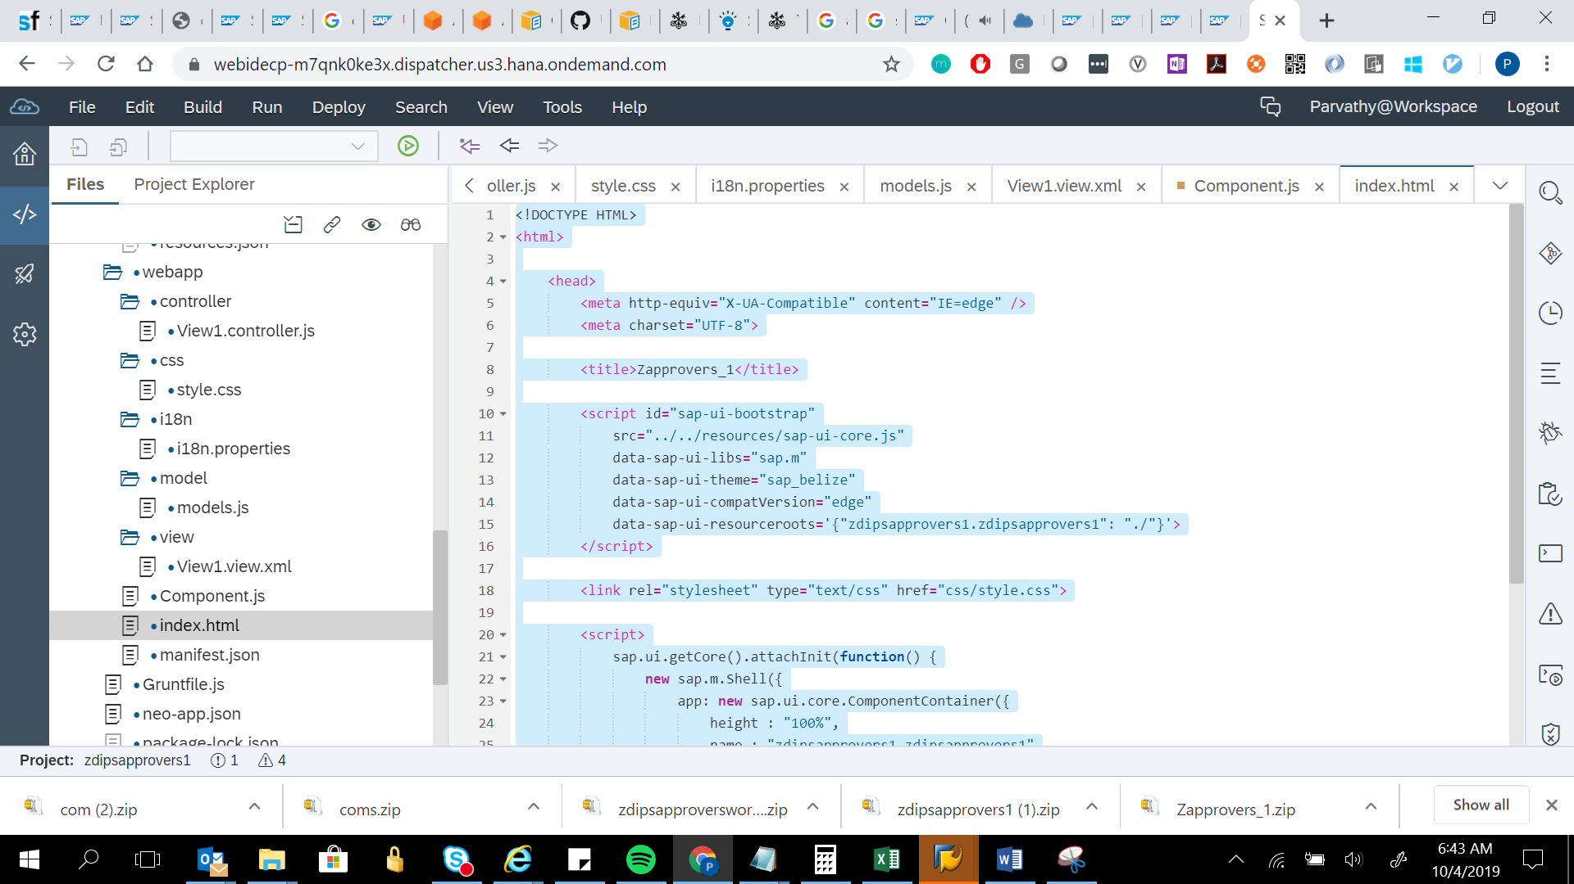

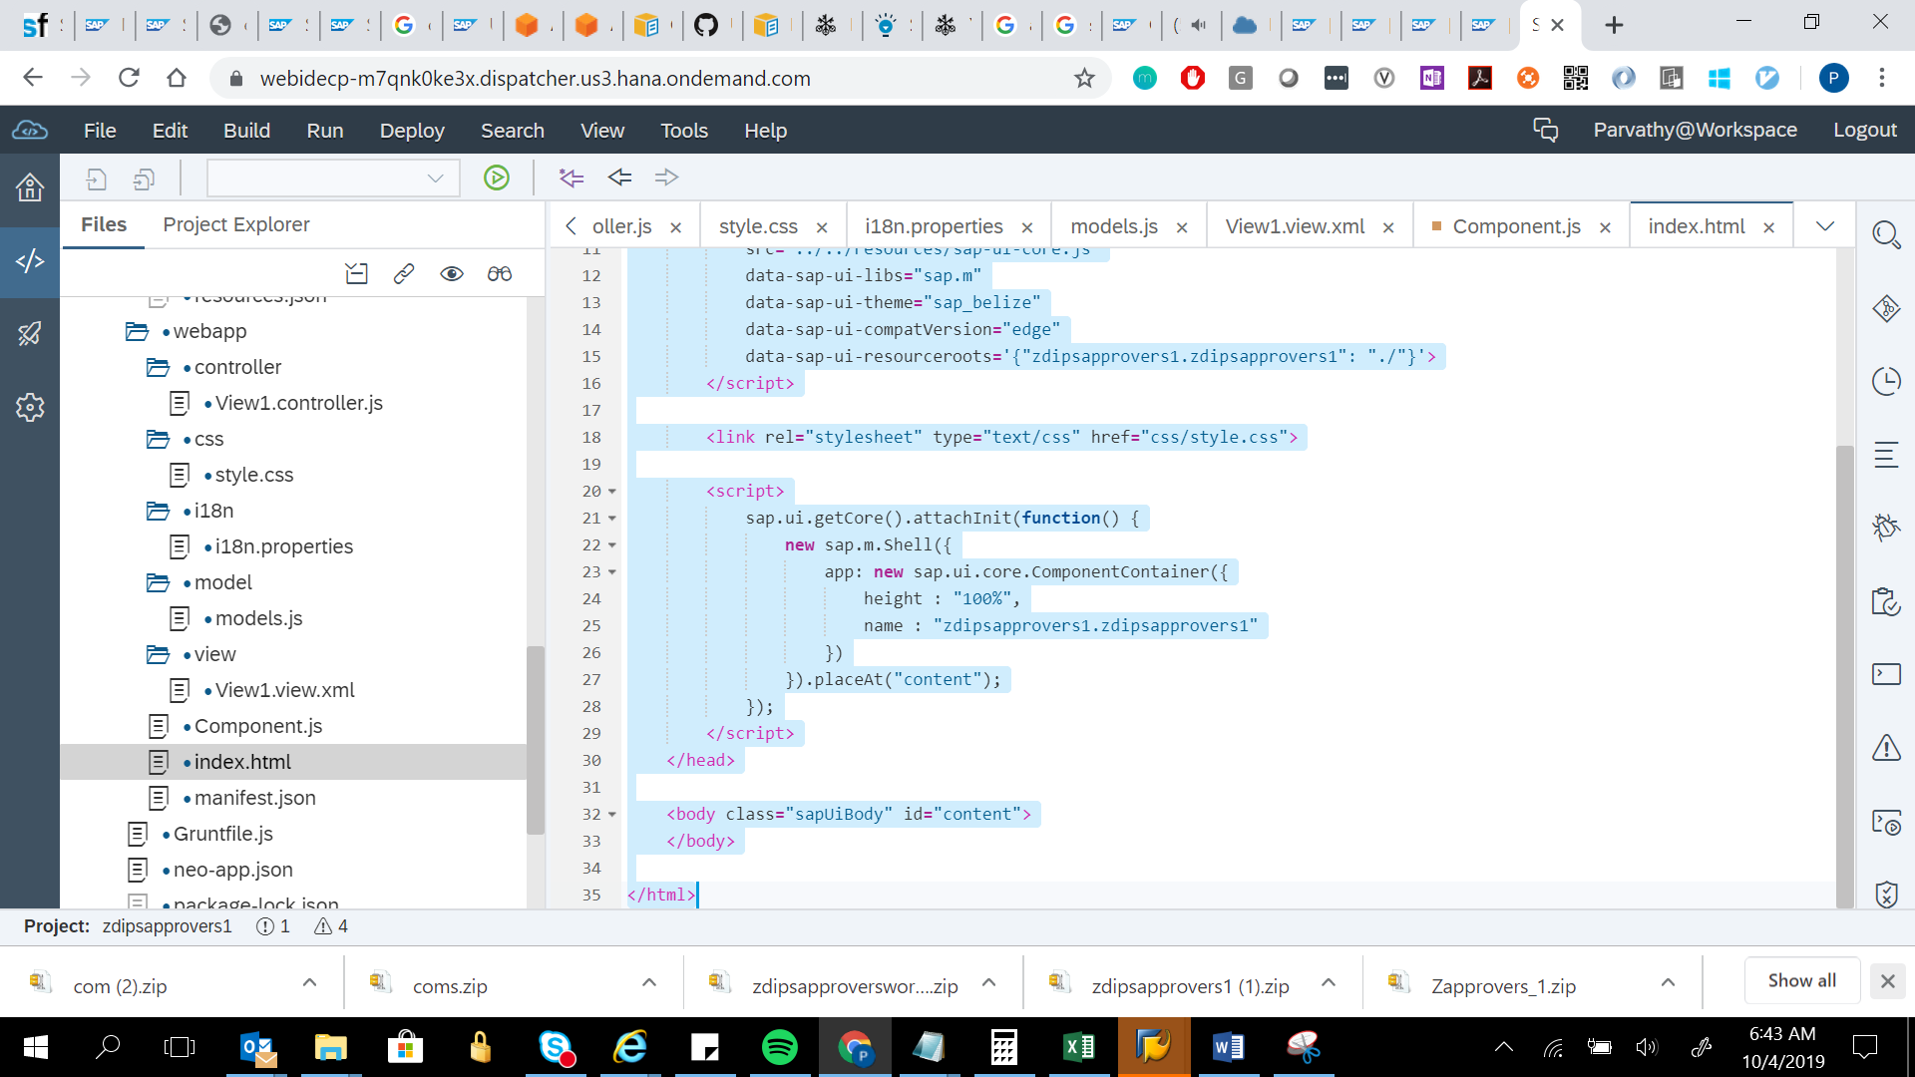

<!DOCTYPE HTML>

<html>

<head>

<meta http-equiv="X-UA-Compatible" content="IE=edge" />

<meta charset="UTF-8">

<title>Zapprovers_1</title>

<script id="sap-ui-bootstrap"

src="../../resources/sap-ui-core.js"

data-sap-ui-libs="sap.m"

data-sap-ui-theme="sap_belize"

data-sap-ui-compatVersion="edge"

data-sap-ui-resourceroots='{"zdipsapprovers1.zdipsapprovers1": "./"}'>

</script>

<link rel="stylesheet" type="text/css" href="css/style.css">

<script>

sap.ui.getCore().attachInit(function() {

new sap.m.Shell({

app: new sap.ui.core.ComponentContainer({

height : "100%",

name : "zdipsapprovers1.zdipsapprovers1"

})

}).placeAt("content");

});

</script>

</head>

<body class="sapUiBody" id="content">

</body>

</html>



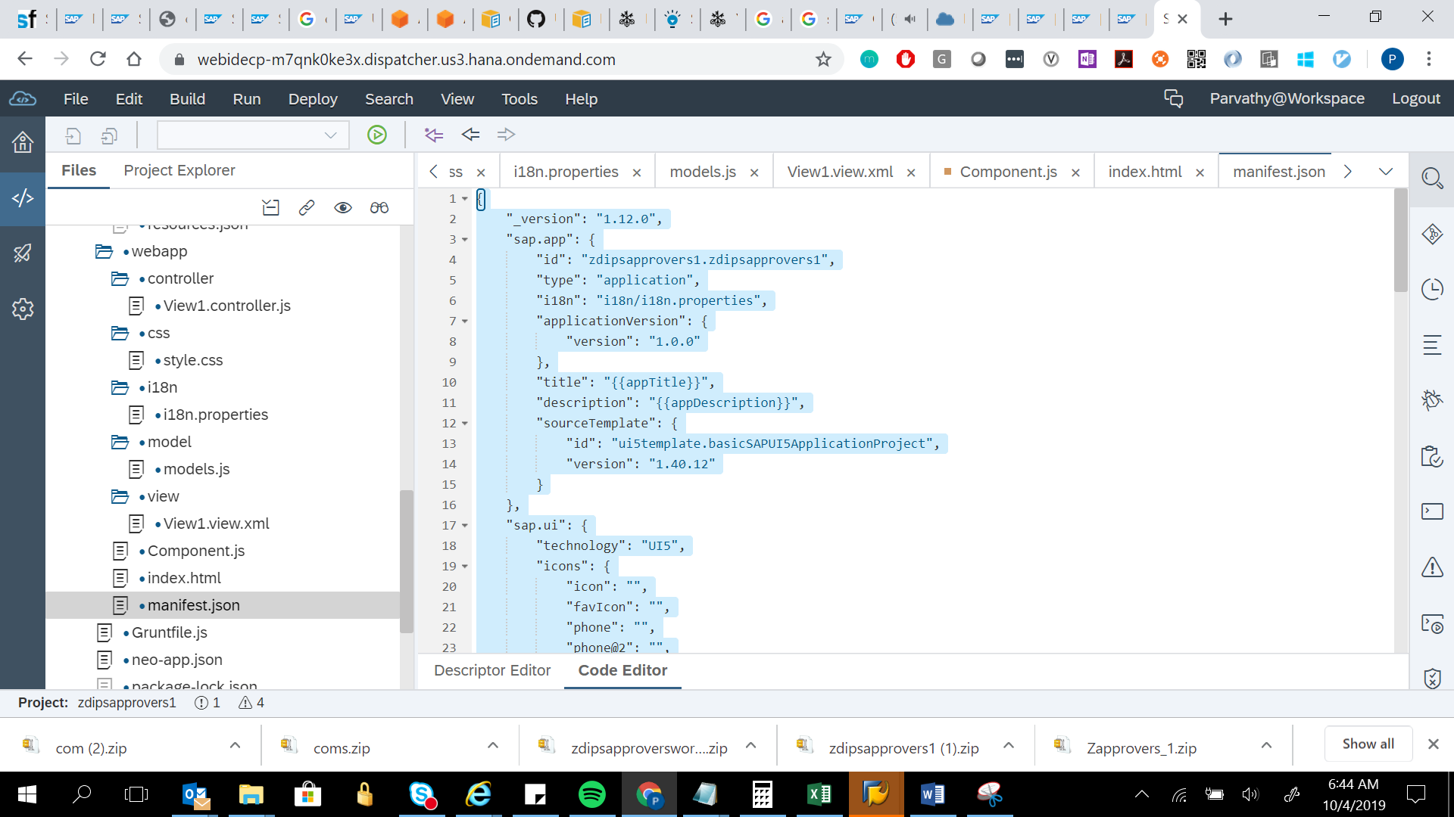

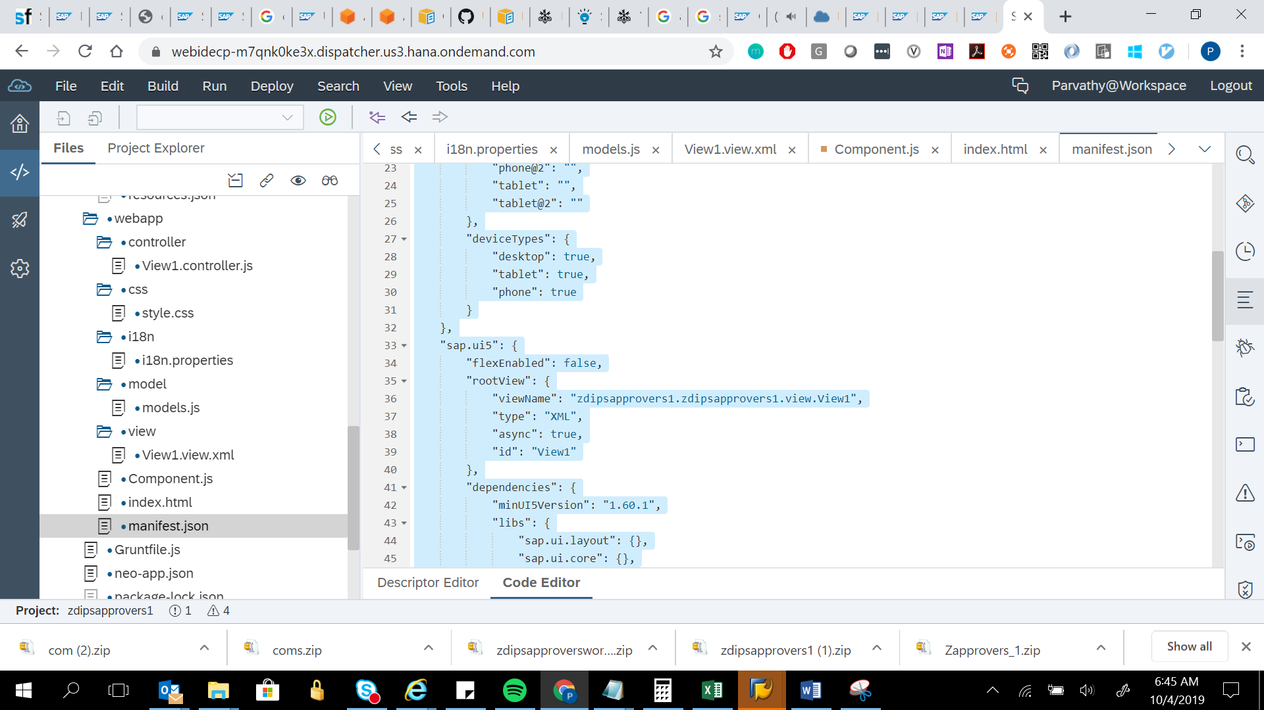

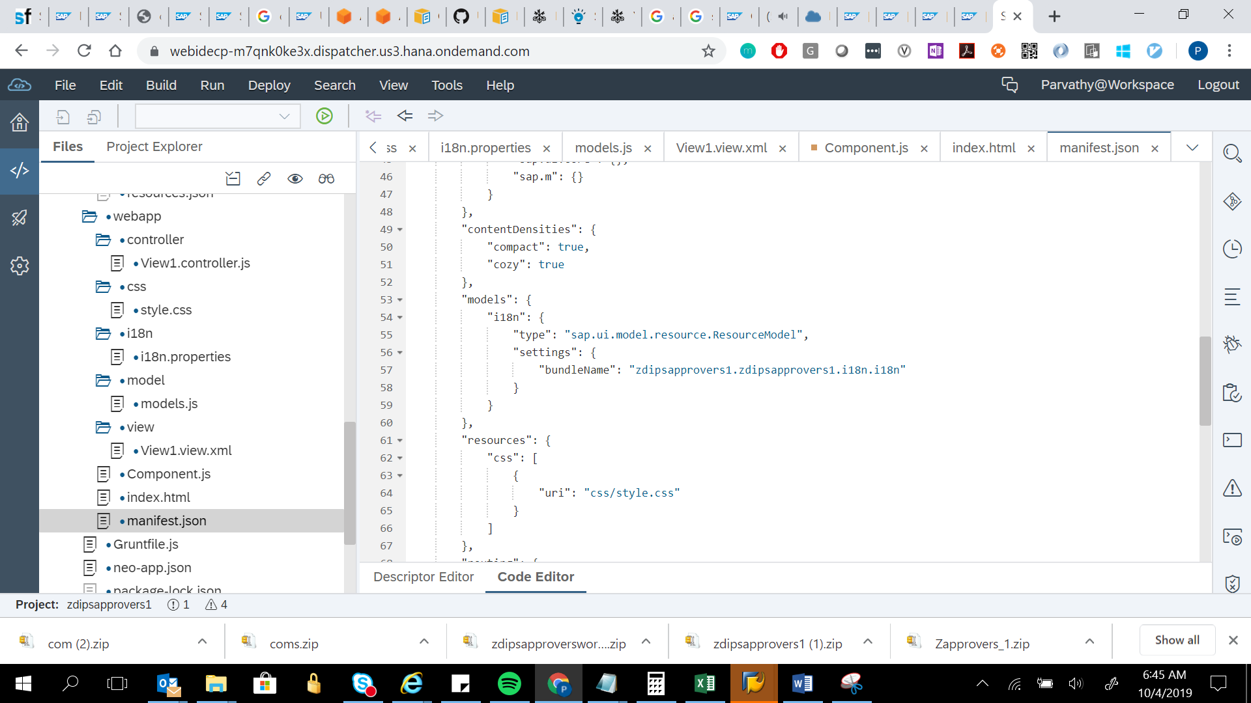

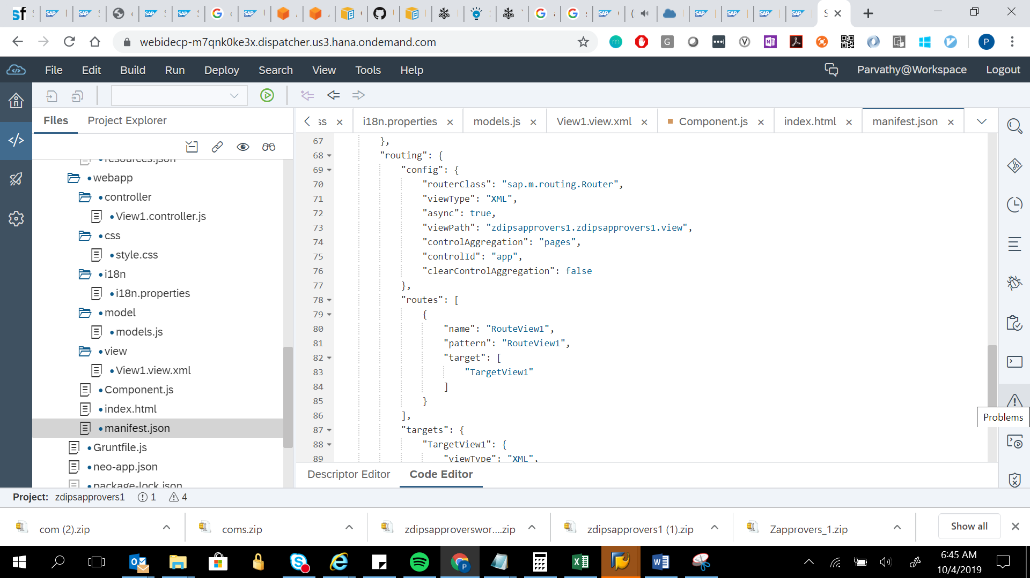

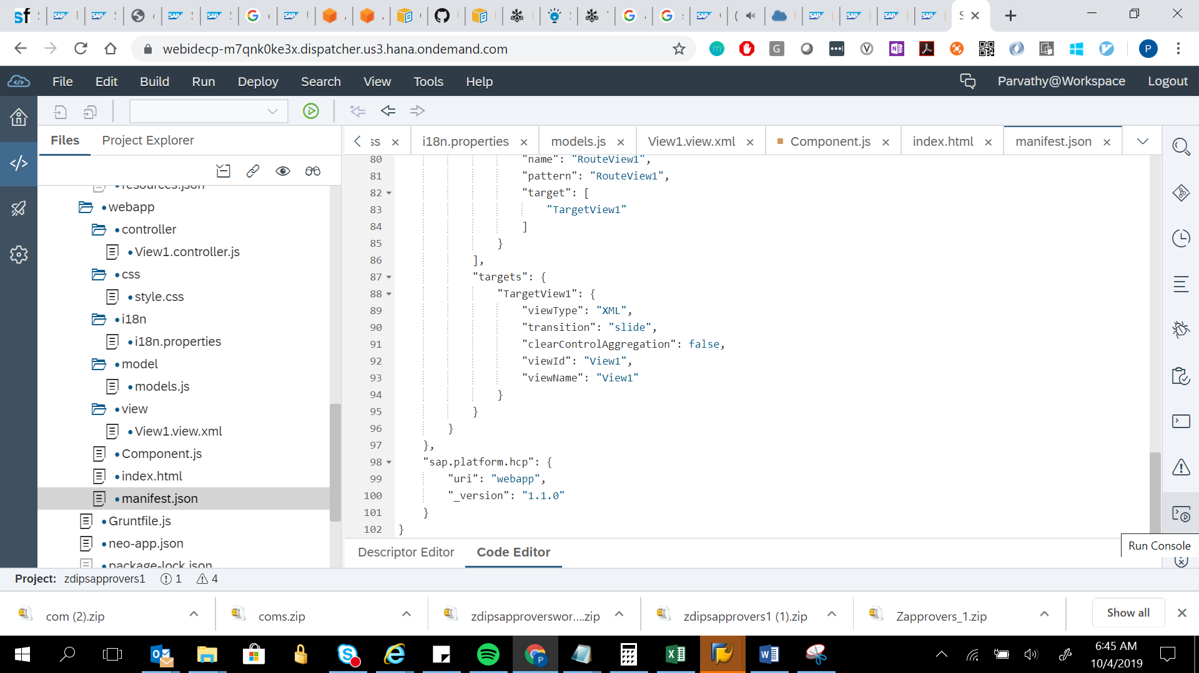

{

"_version": "1.12.0",

"sap.app": {

"id": "zdipsapprovers1.zdipsapprovers1",

"type": "application",

"i18n": "i18n/i18n.properties",

"applicationVersion": {

"version": "1.0.0"

},

"title": "{{appTitle}}",

"description": "{{appDescription}}",

"sourceTemplate": {

"id": "ui5template.basicSAPUI5ApplicationProject",

"version": "1.40.12"

}

},

"sap.ui": {

"technology": "UI5",

"icons": {

"icon": "",

"favIcon": "",

"phone": "",

"phone@2": "",

"tablet": "",

"tablet@2": ""

},

"deviceTypes": {

"desktop": true,

"tablet": true,

"phone": true

}

},

"sap.ui5": {

"flexEnabled": false,

"rootView": {

"viewName": "zdipsapprovers1.zdipsapprovers1.view.View1",

"type": "XML",

"async": true,

"id": "View1"

},

"dependencies": {

"minUI5Version": "1.60.1",

"libs": {

"sap.ui.layout": {},

"sap.ui.core": {},

"sap.m": {}

}

},

"contentDensities": {

"compact": true,

"cozy": true

},

"models": {

"i18n": {

"type": "sap.ui.model.resource.ResourceModel",

"settings": {

"bundleName": "zdipsapprovers1.zdipsapprovers1.i18n.i18n"

}

}

},

"resources": {

"css": [

{

"uri": "css/style.css"

}

]

},

"routing": {

"config": {

"routerClass": "sap.m.routing.Router",

"viewType": "XML",

"async": true,

"viewPath": "zdipsapprovers1.zdipsapprovers1.view",

"controlAggregation": "pages",

"controlId": "app",

"clearControlAggregation": false

},

"routes": [

{

"name": "RouteView1",

"pattern": "RouteView1",

"target": [

"TargetView1"

]

}

],

"targets": {

"TargetView1": {

"viewType": "XML",

"transition": "slide",

"clearControlAggregation": false,

"viewId": "View1",

"viewName": "View1"

}

}

}

},

"sap.platform.hcp": {

"uri": "webapp",

"_version": "1.1.0"

}

}



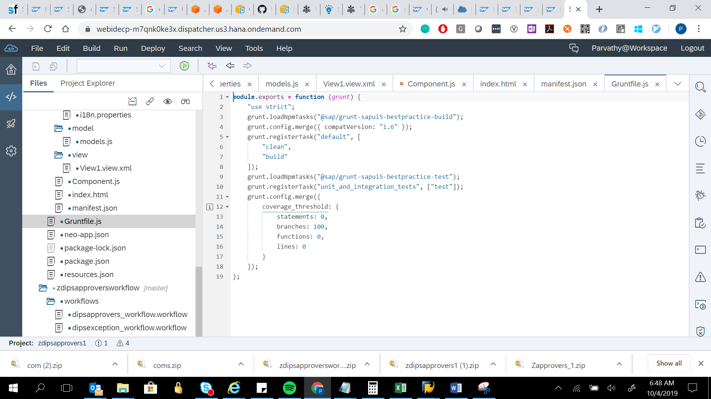

module.exports = function (grunt) {

"use strict";

grunt.loadNpmTasks("@sap/grunt-sapui5-bestpractice-build");

grunt.config.merge({ compatVersion: "1.6" });

grunt.registerTask("default", [

"clean",

"build"

]);

grunt.loadNpmTasks("@sap/grunt-sapui5-bestpractice-test");

grunt.registerTask("unit_and_integration_tests", ["test"]);

grunt.config.merge({

coverage_threshold: {

statements: 0,

branches: 100,

functions: 0,

lines: 0

}

});

};



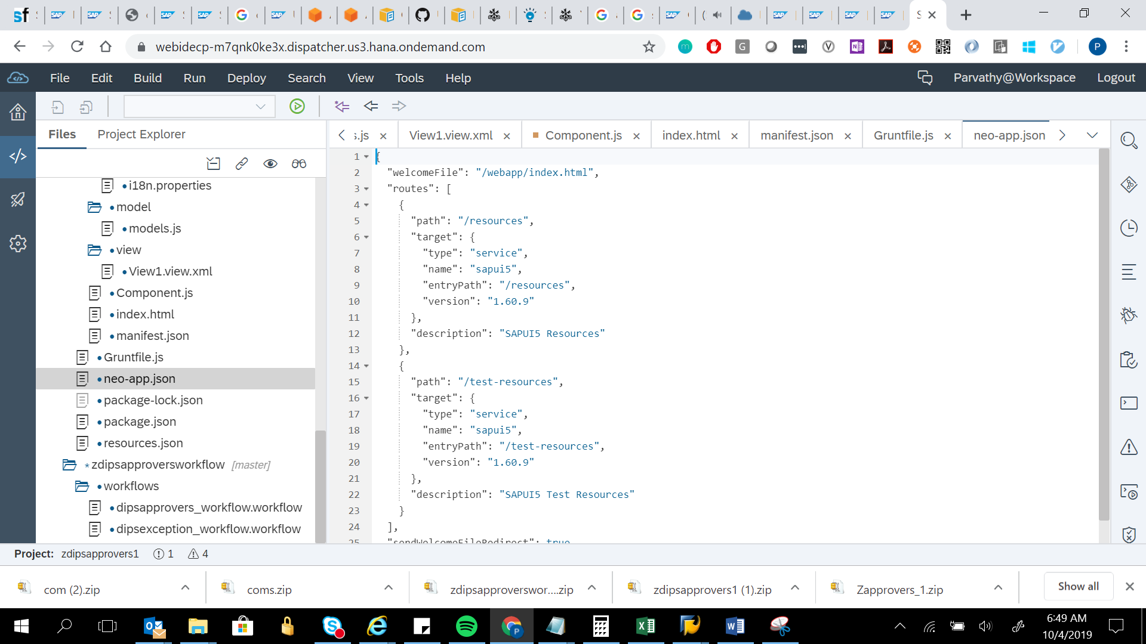

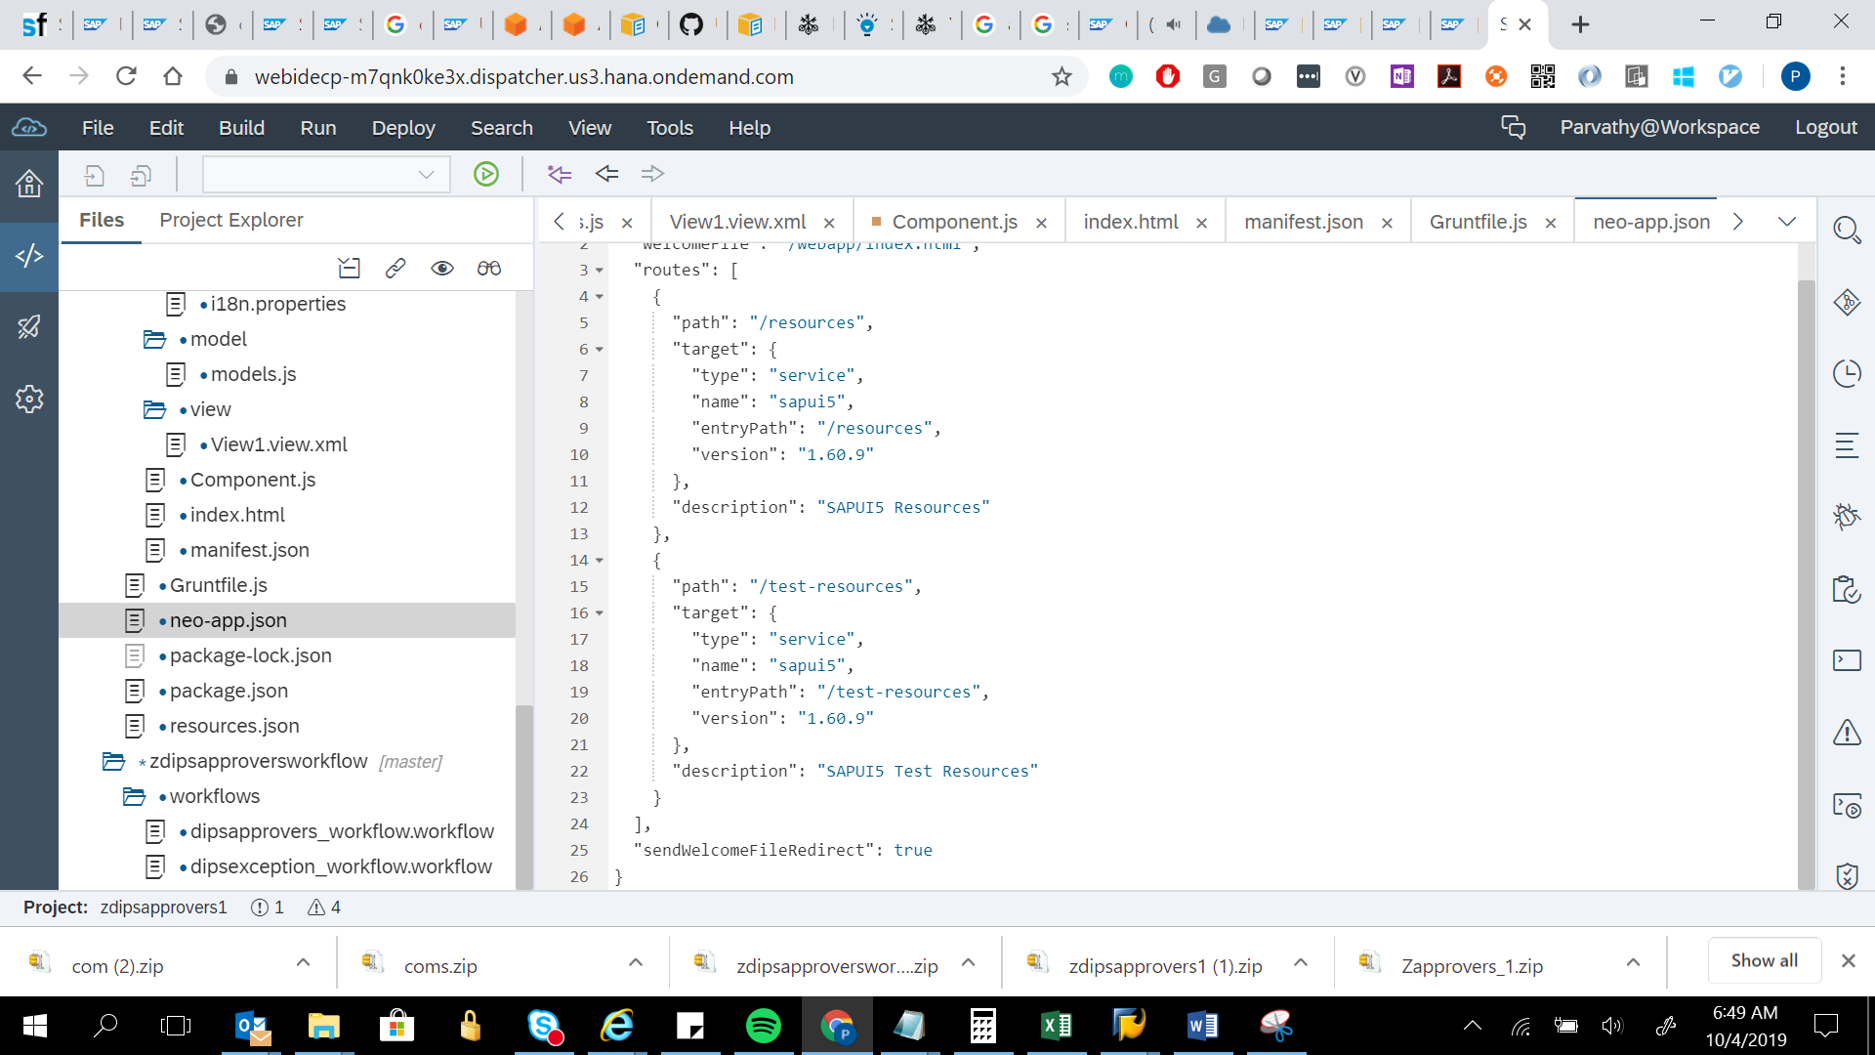

{

"welcomeFile": "/webapp/index.html",

"routes": [

{

"path": "/resources",

"target": {

"type": "service",

"name": "sapui5",

"entryPath": "/resources",

"version": "1.60.9"

},

"description": "SAPUI5 Resources"

},

{

"path": "/test-resources",

"target": {

"type": "service",

"name": "sapui5",

"entryPath": "/test-resources",

"version": "1.60.9"

},

"description": "SAPUI5 Test Resources"

}

],

"sendWelcomeFileRedirect": true

}

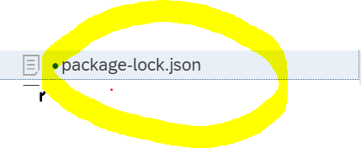

It’s a huge file.around 8905 lines of code.So not taking a copy



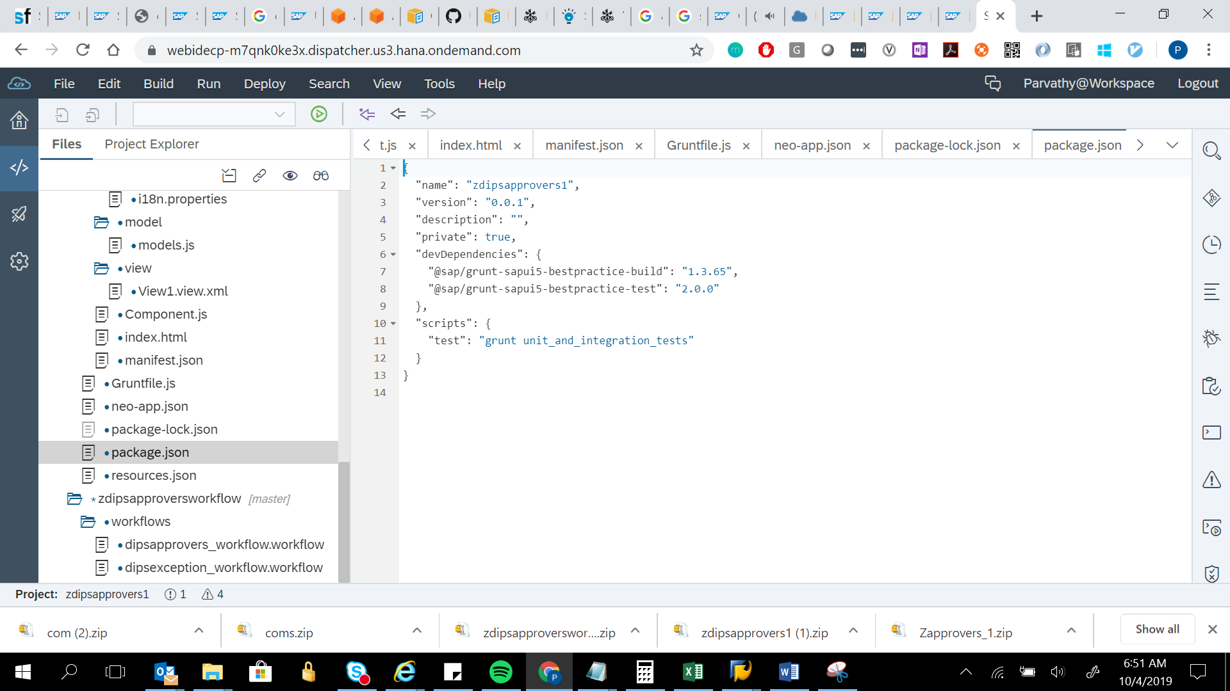

{

"name": "zdipsapprovers1",

"version": "0.0.1",

"description": "",

"private": true,

"devDependencies": {

"@sap/grunt-sapui5-bestpractice-build": "1.3.65",

"@sap/grunt-sapui5-bestpractice-test": "2.0.0"

},

"scripts": {

"test": "grunt unit_and_integration_tests"

}

}



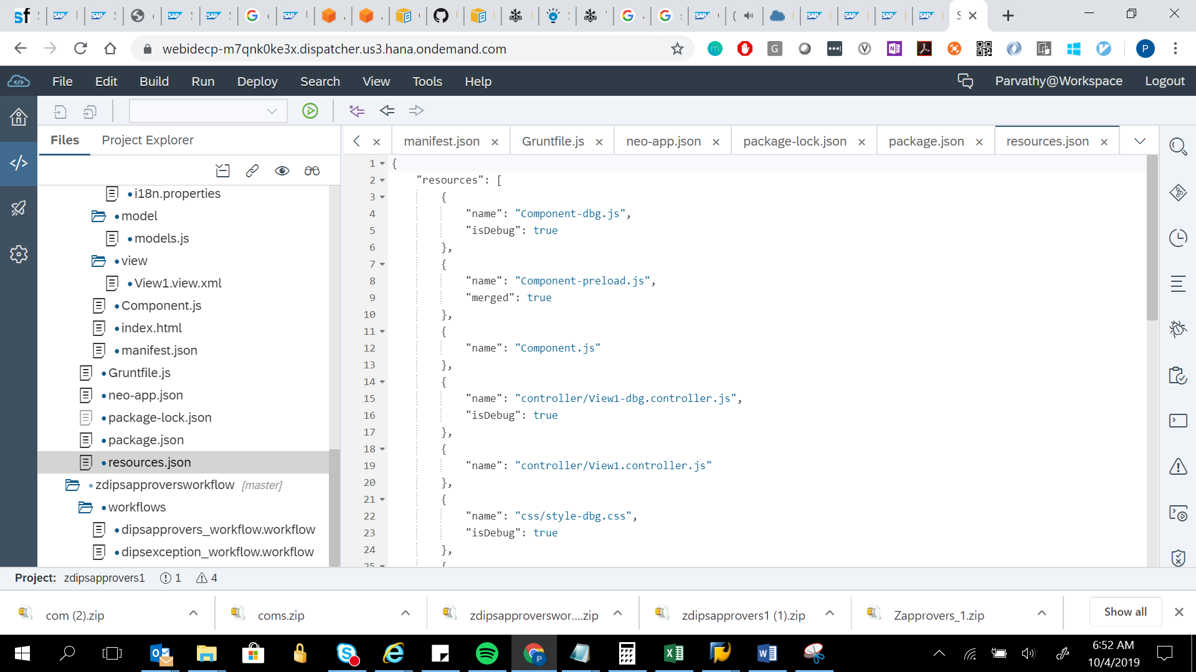

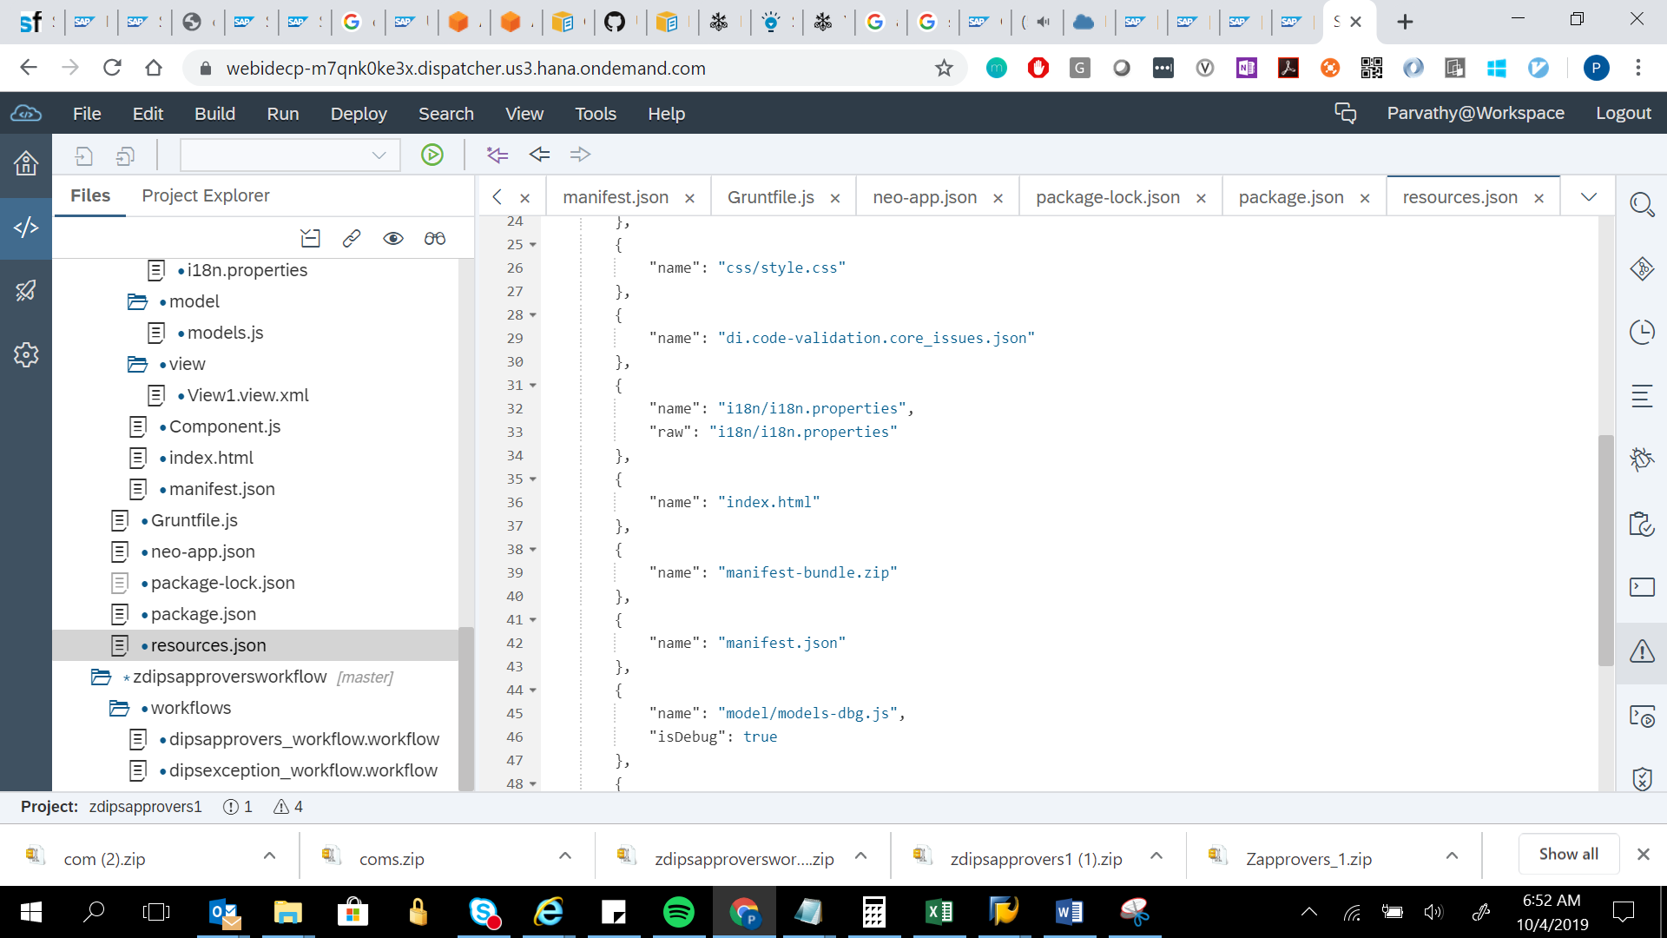

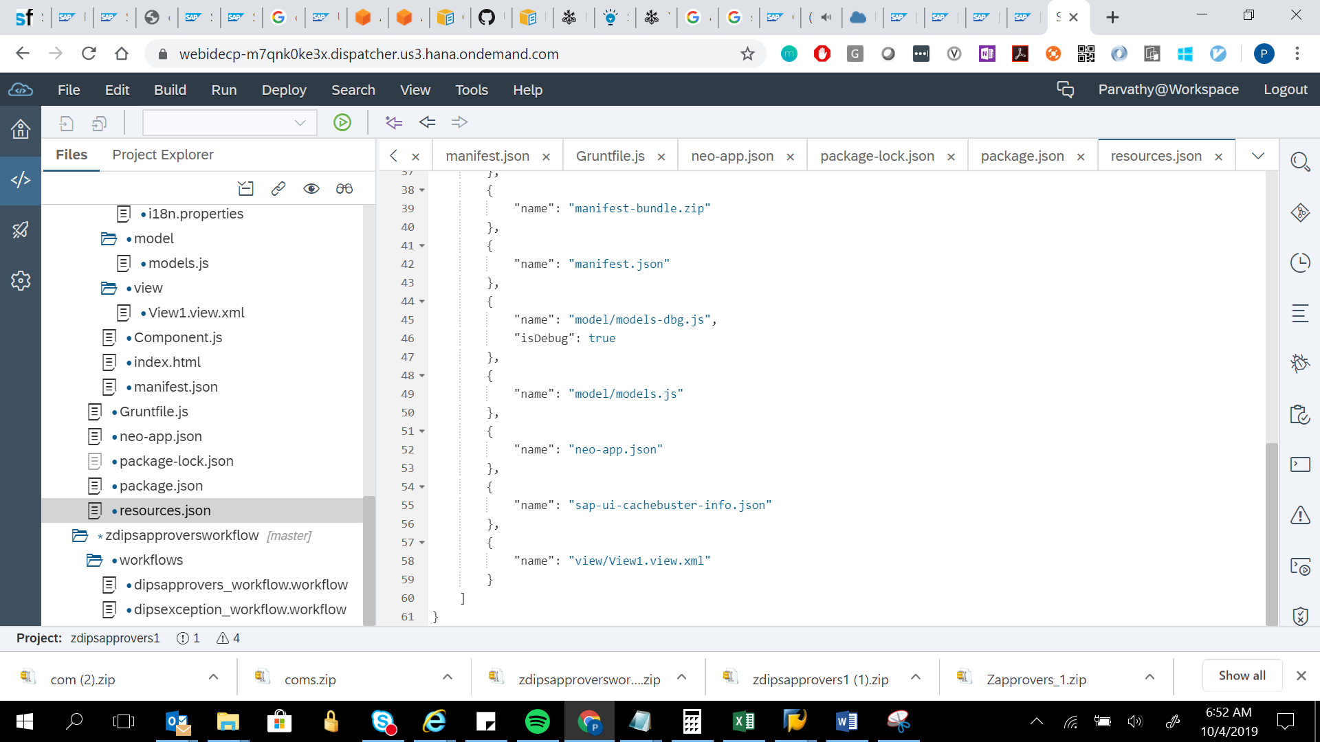

{

"resources": [

{

"name": "Component-dbg.js",

"isDebug": true

},

{

"name": "Component-preload.js",

"merged": true

},

{

"name": "Component.js"

},

{

"name": "controller/View1-dbg.controller.js",

"isDebug": true

},

{

"name": "controller/View1.controller.js"

},

{

"name": "css/style-dbg.css",

"isDebug": true

},

{

"name": "css/style.css"

},

{

"name": "di.code-validation.core_issues.json"

},

{

"name": "i18n/i18n.properties",

"raw": "i18n/i18n.properties"

},

{

"name": "index.html"

},

{

"name": "manifest-bundle.zip"

},

{

"name": "manifest.json"

},

{

"name": "model/models-dbg.js",

"isDebug": true

},

{

"name": "model/models.js"

},

{

"name": "neo-app.json"

},

{

"name": "sap-ui-cachebuster-info.json"

},

{

"name": "view/View1.view.xml"

}

]

}

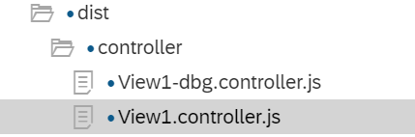

Dist file is created after the application code is built.

View1.controller and view1-dbg.controller are same.